GIS PRACTICALS:

1.] Create a map of your own residential area

* Add 4 Area (id, name)
* Add 2 Highways (id, name)
* Add 2 railway track (id, name, line)

SOLUTION:

Create a new Project then,

**Add a Base Map**

1. Go to **"Plugins"** > **"Manage and Install Plugins"**.
2. Search for **"QuickMapServices"** and install it.
3. Once installed, go to **"Web"** > **"QuickMapServices"** > **"Google"** > **"Google Satellite"** (or use OpenStreetMap).

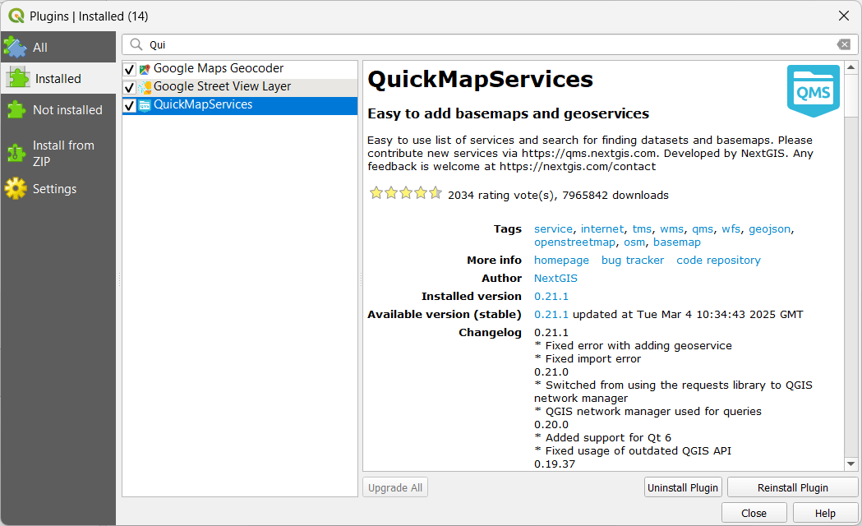

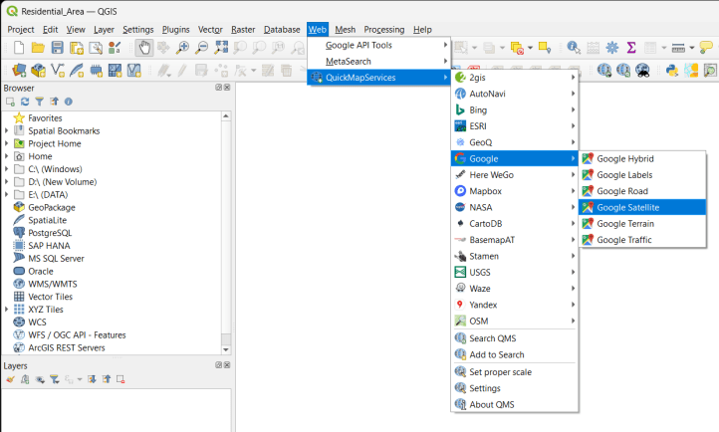

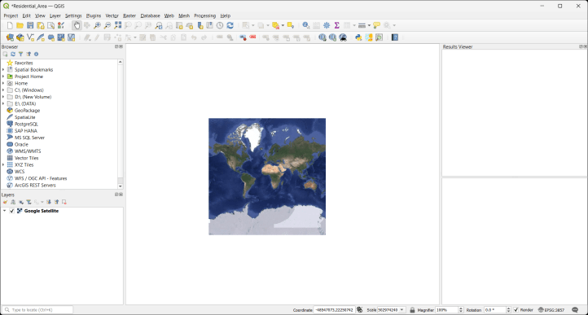

**Step 4: Create a New Shapefile Layer for Areas**

1. Click on **"Layer"** > **"Create Layer"** > **"New Shapefile Layer"**.
2. Set **File Name** as areas.shp.
3. **Geometry Type**: Select **Polygon** (for areas).
4. Click **"Add Fields"**:
   * id (Integer)
   * name (Text)
5. Click **"OK"**.
6. The layer areas.shp appears in the **Layers Panel**.

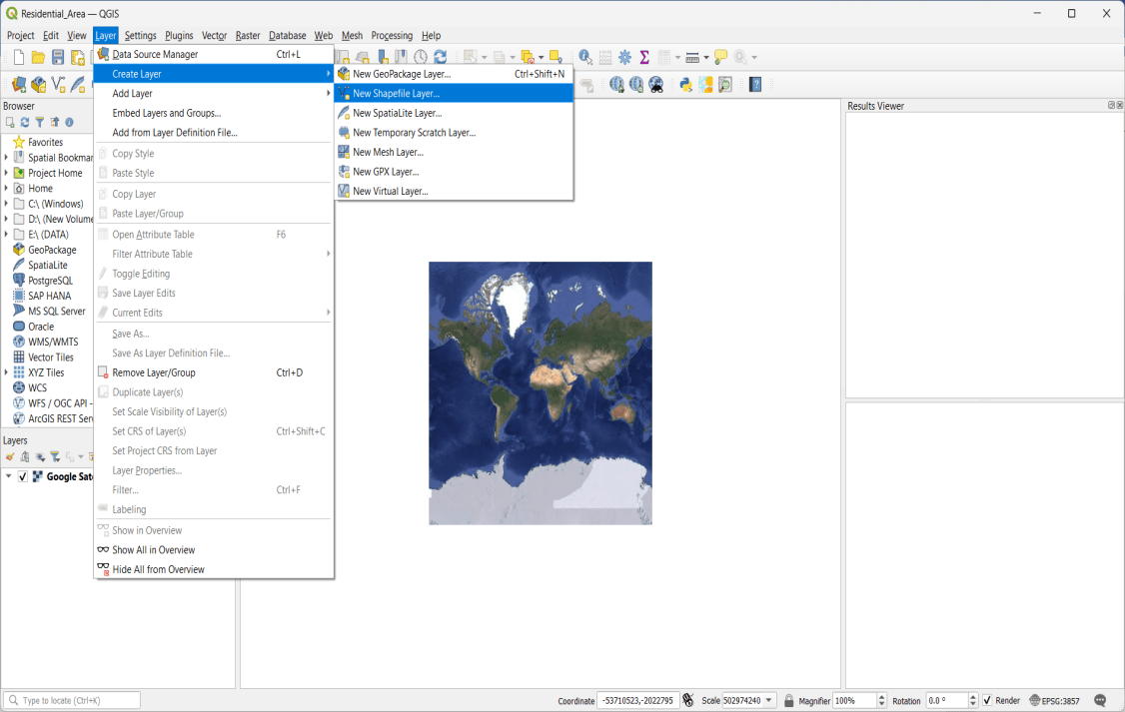

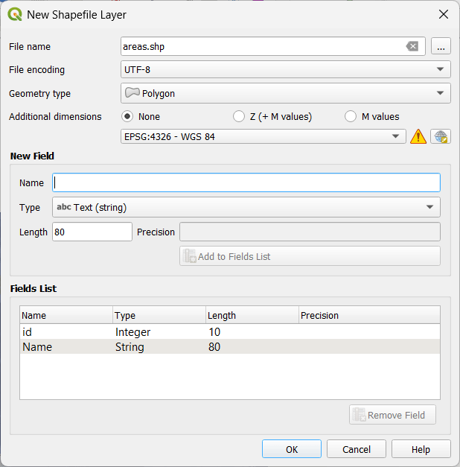

**Add Areas (Polygons)**

1. Select the areas.shp layer.
2. Click **"Toggle Editing"** (pencil icon).
3. Click **"Add Polygon Feature"**.
4. Draw four different area boundaries using the map.
5. After each area, **right-click** to finish and enter **ID** and **Name** (e.g., "1, Sion").
6. Click **"Save Layer Edits"** and **"Toggle Editing"** to stop.

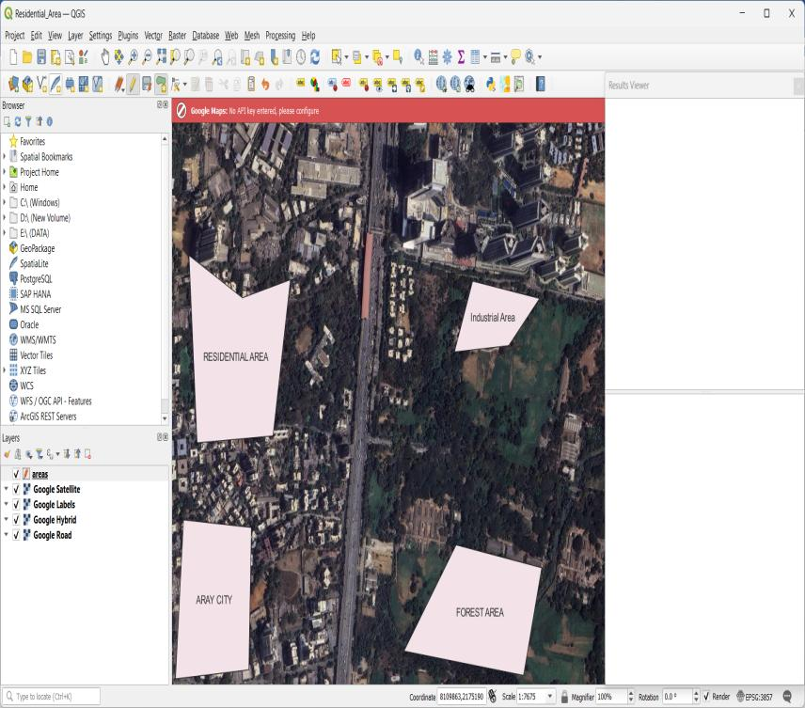

**Create a New Shapefile Layer for Highways**

1. Click **Layer** → **Create Layer** → **New Shapefile Layer**.
2. Set **File Name** to highways.shp and choose **Line** as Geometry Type.
3. Click **Add Field**:
   * Name: id, Type: **Integer**
   * Name: name, Type: **Text**
4. Click **OK** to create the layer.

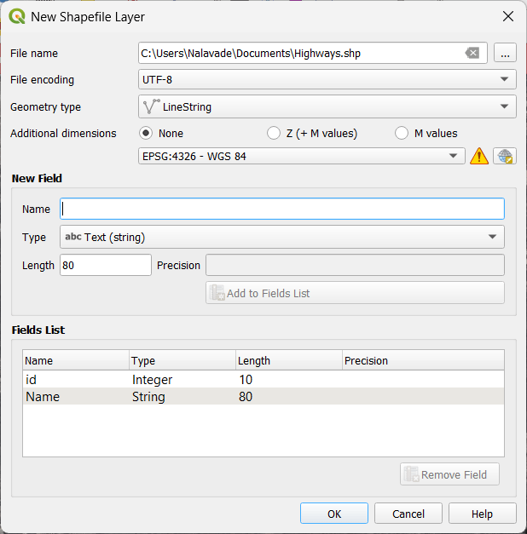

**Create a New Shapefile Layer for Railway Tracks**

1. Click **Layer** → **Create Layer** → **New Shapefile Layer**.
2. Set **File Name** to railways.shp and choose **Line** as Geometry Type.
3. Click **Add Field**:
   * Name: id, Type: **Integer**
   * Name: name, Type: **Text**
   * Name: line, Type: **Text** (to specify the railway line name)
4. Click **OK** to create the layer.

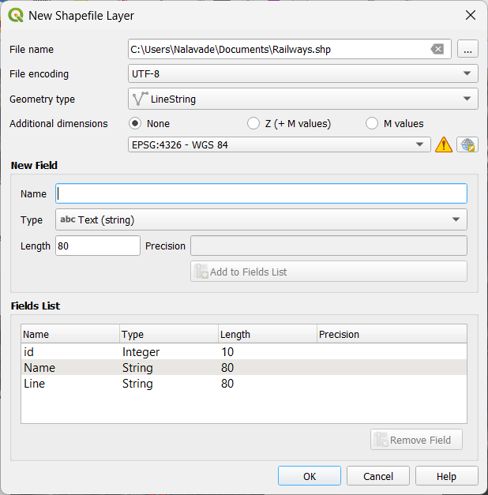

**Digitize (Draw) the 2 Railway Tracks**

1. Right-click railways.shp in the **Layers Panel** → Click **Toggle Editing**.
2. Click **Add Line Feature** from the toolbar.
3. Click to draw the railway track → Right-click to finish.
4. Enter id, name, and line (e.g., 1, "Track 1", "Main Line").
5. Click **OK**.
6. Repeat for the second railway track.
7. Click **Toggle Editing** → **Save Layer Edits**.

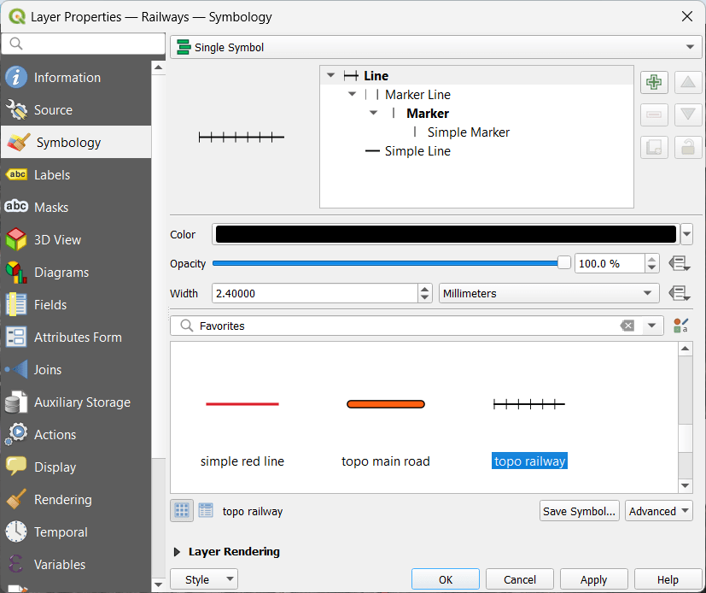

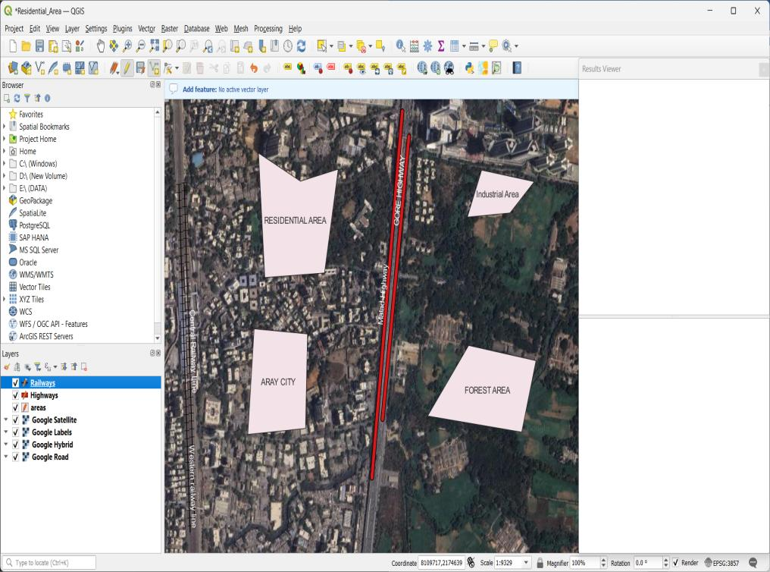

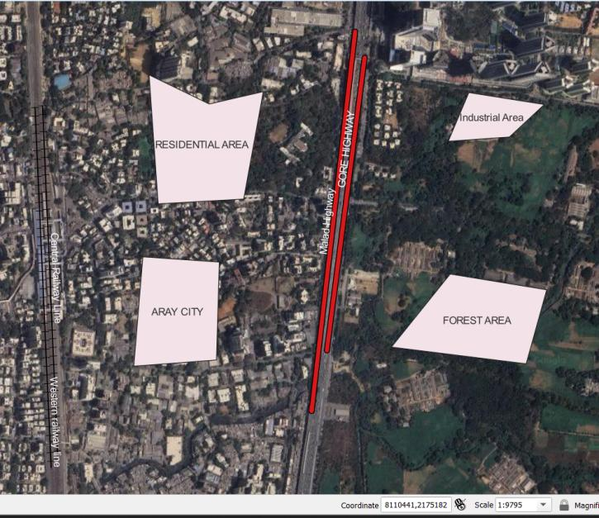

**Save and Export the Map**

1. Click **Project** → **Save** to save your work.
2. Click **Layout Manager** → **New Print Layout**.
3. Click **Add Map** and draw the map on the layout.
4. Click **Layout** → **Export as PDF/PNG** to save the map.

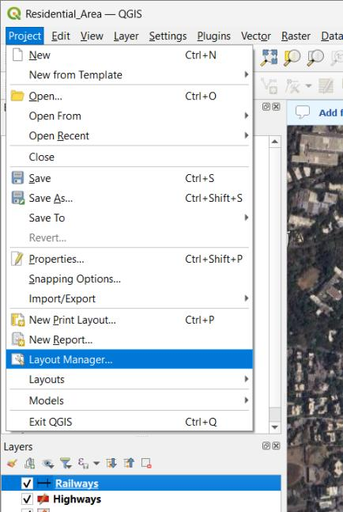

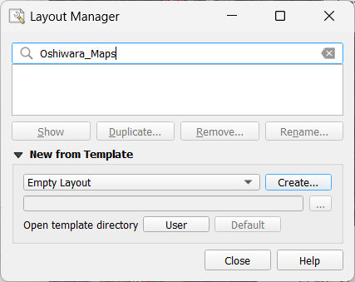

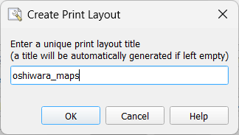

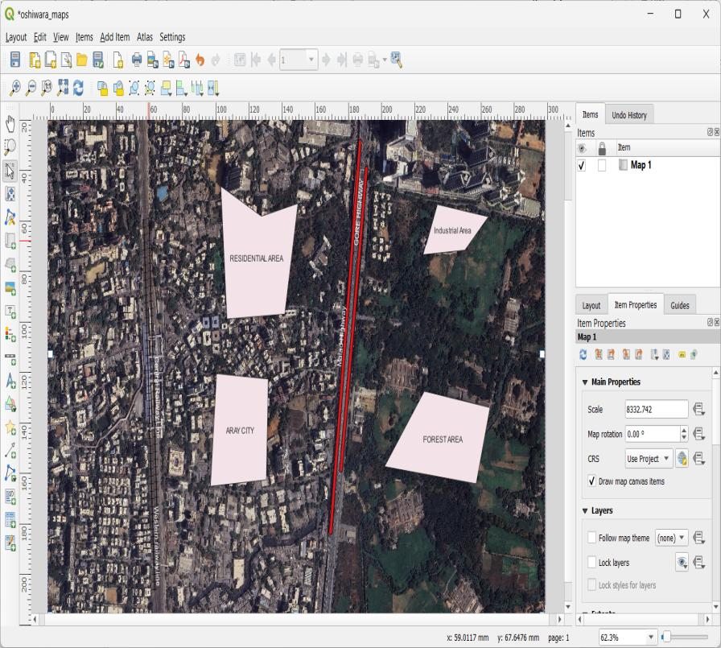

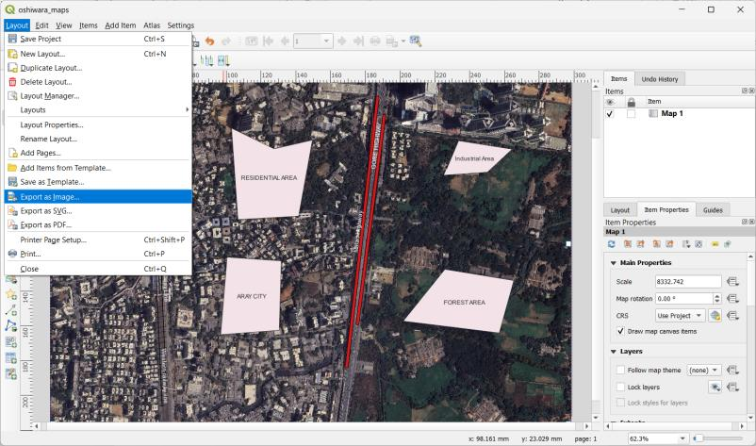

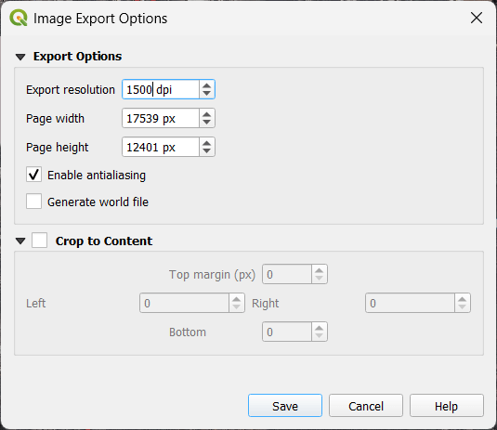

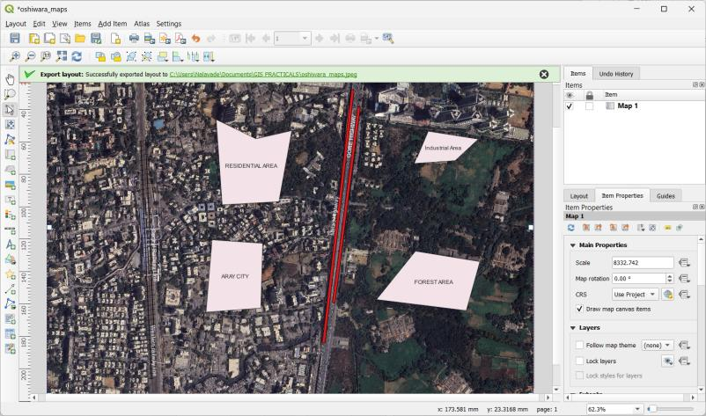

Output: Message will appear where the image of the map is saved .

2.] Use “Mumbai Map”: (same as Practical 4 of Journal)

1. Add scale to 40000, CRS-WGS 84
2. Add legend
3. Add scale Bar
4. Set proper suitable properties.
5. Give proper name to map
6. Import CSV File

(Dataset : https://drive.google.com/drive/folders/1j38KW-RdNo7YqvIsqKjSRoZCkSFQYWHv )

SOLUTION:

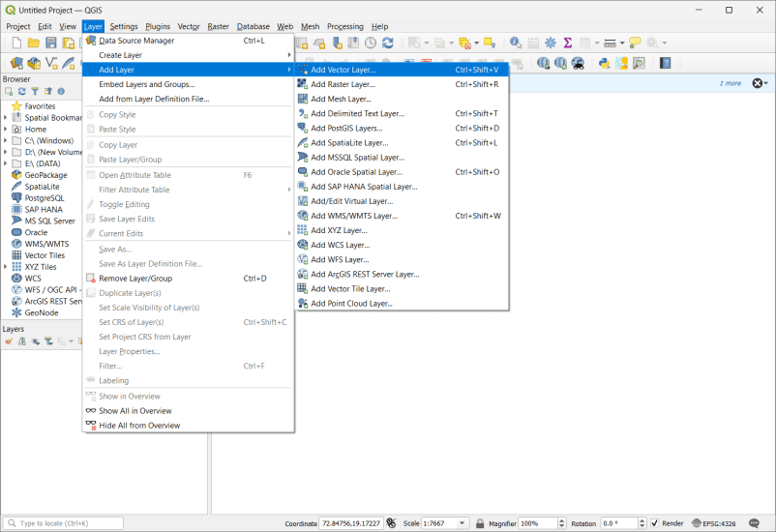

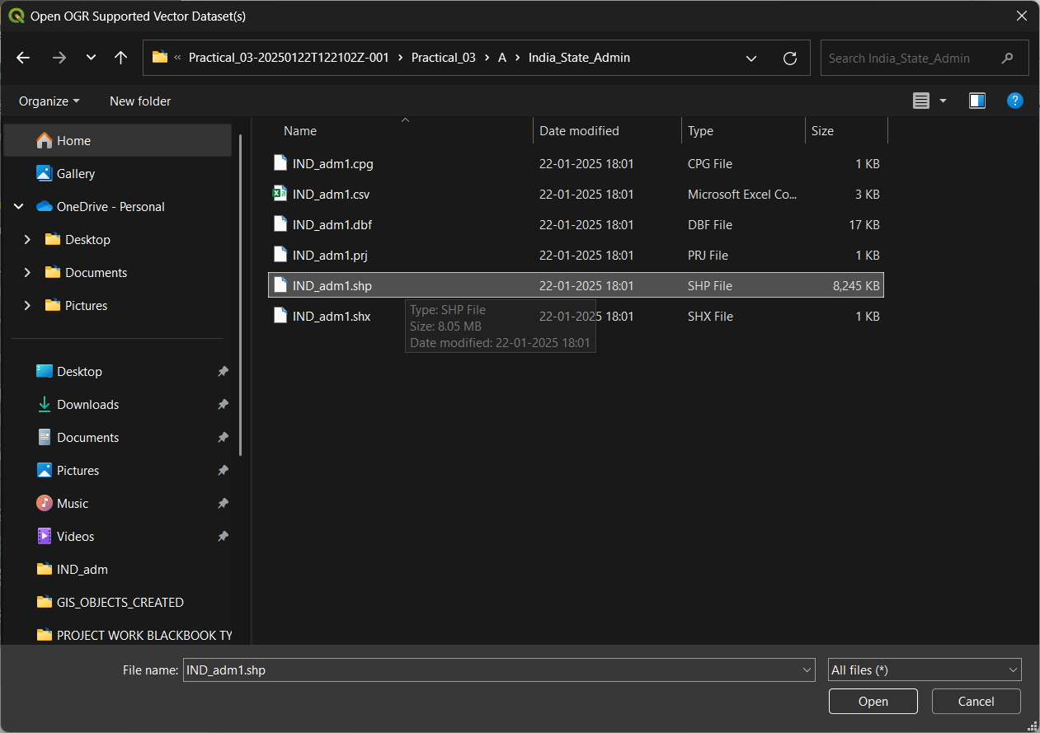

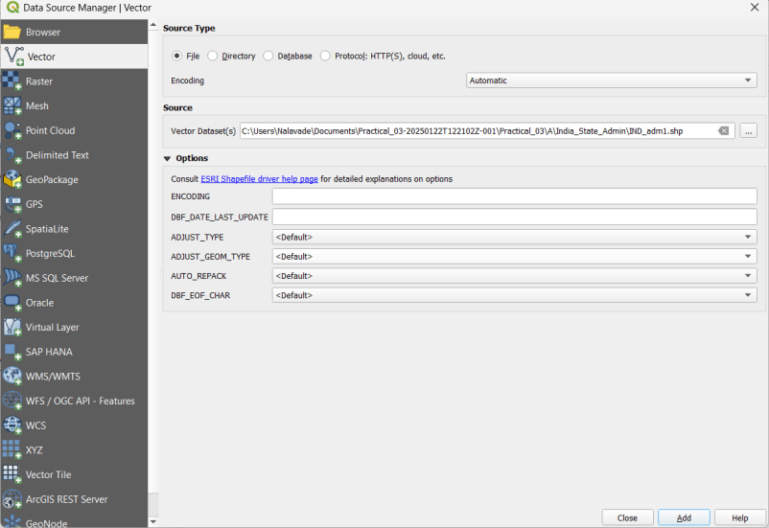

**The files we need for this part of the practical are:**

C:\Users\Nalavade\Downloads\Practical_03-20250122T122102Z-001\Practical_03\A\India_State_Admin\IND_adm1.shp

C:\Users\Nalavade\Downloads\Practical_03-20250122T122102Z-001\Practical_03\A\maharashtra_administrative\maharashtra_administrative.shp

C:\Users\Nalavade\Downloads\Practical_03-20250122T122102Z-001\Practical_03\A\maharashtra_coastline\maharashtra_coastline.shp

C:\Users\Nalavade\Downloads\Practical_03-20250122T122102Z-001\Practical_03\A\maharashtra_highway\maharashtra_highway.shp

C:\Users\Nalavade\Downloads\Practical_03-20250122T122102Z-001\Practical_03\A\maharashtra_location\maharashtra_location.shp

C:\Users\Nalavade\Downloads\Practical_03-20250122T122102Z-001\Practical_03\A\maharashtra_natural\maharashtra_natural.shp

C:\Users\Nalavade\Downloads\Practical_03-20250122T122102Z-001\Practical_03\A\maharashtra_poi\maharashtra_poi.shp

C:\Users\Nalavade\Downloads\Practical_03-20250122T122102Z-001\Practical_03\A\maharashtra_water\maharashtra_water.shp

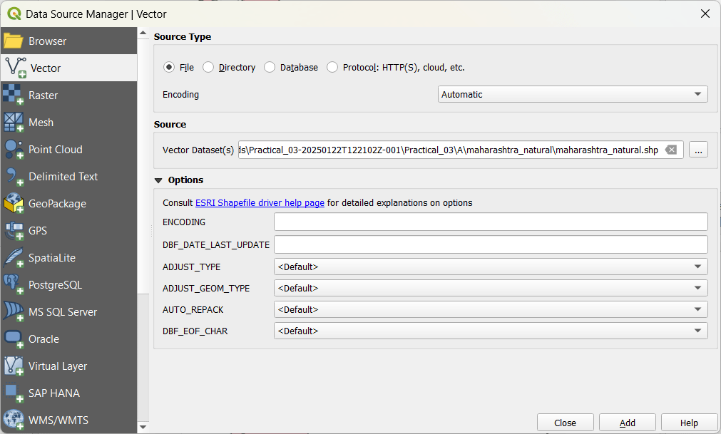

Add all the above layers mentioned and then close.

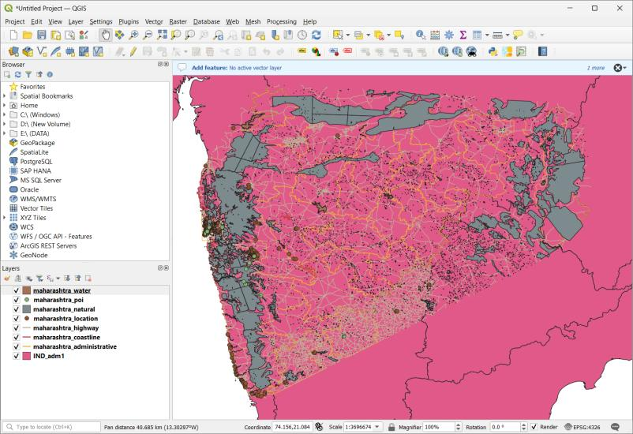

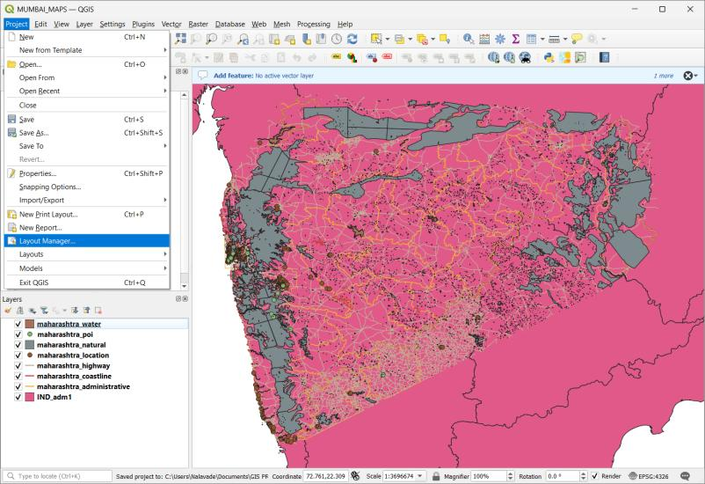

ZOOM IN FOR MUMBAI:

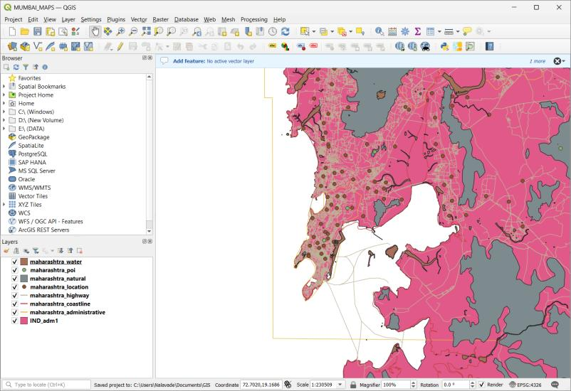

!. CRS-WGS 84 set

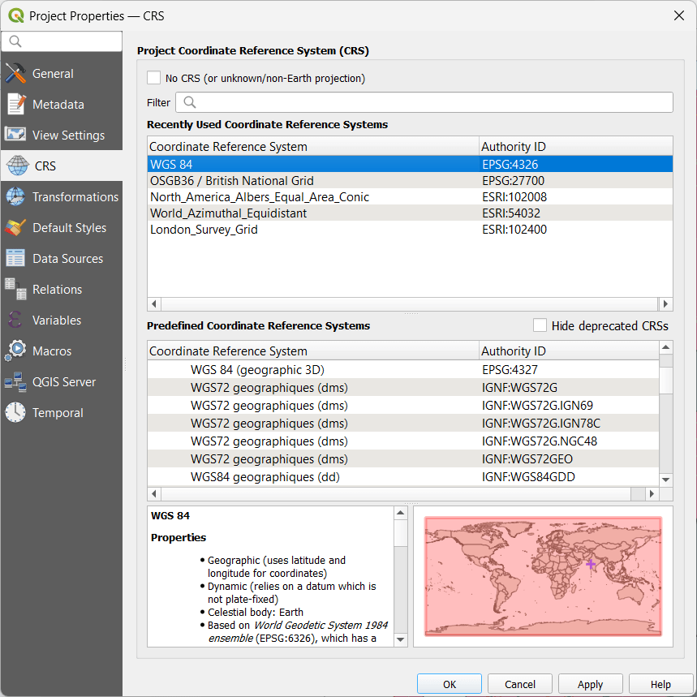

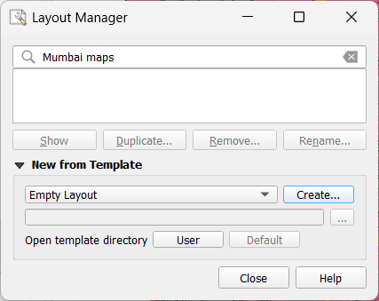

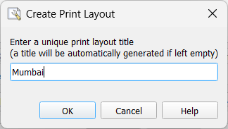

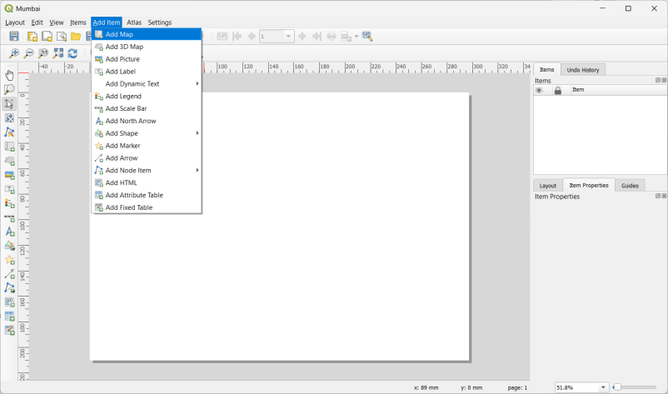

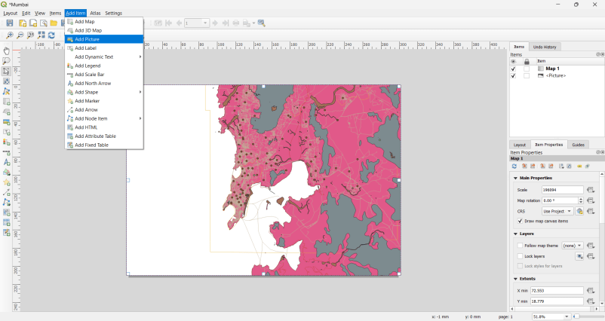

2. add legend

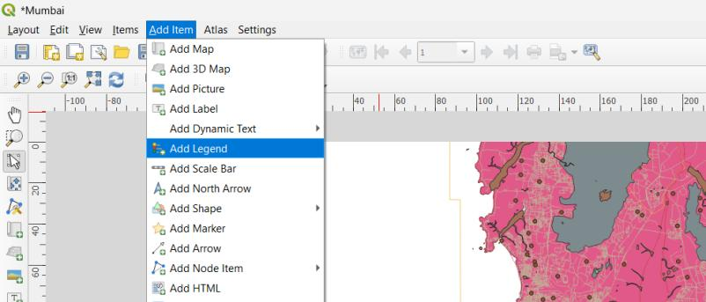

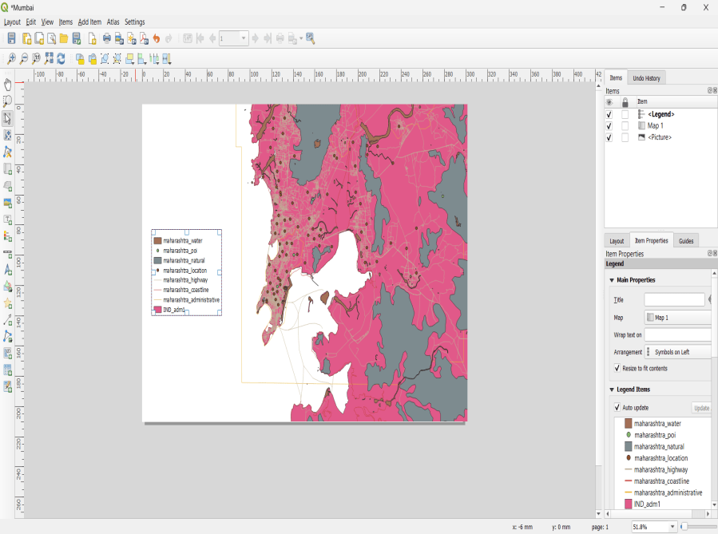

3. Add scale Bar

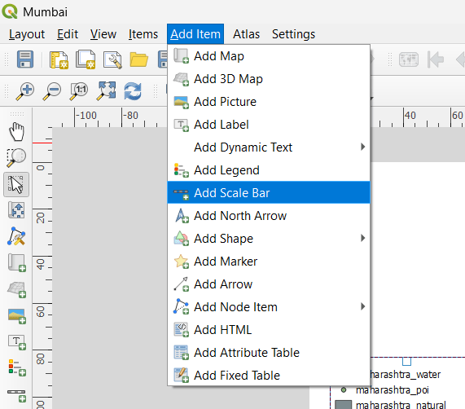

Draw wherever you would like to represent this and do property changes for scalebar

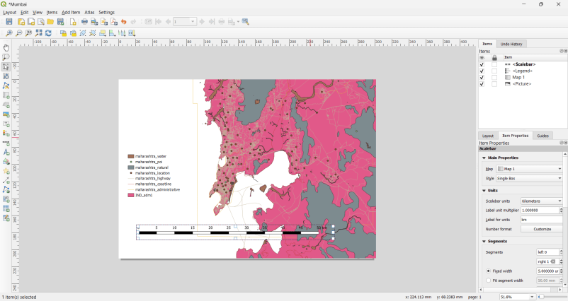

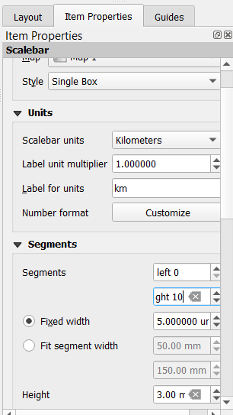

1. Proper name to map

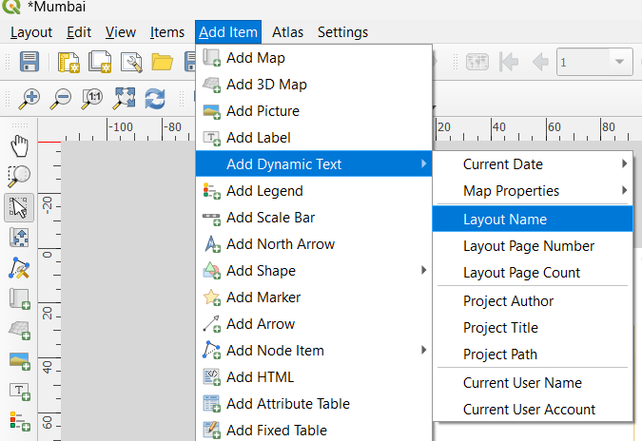

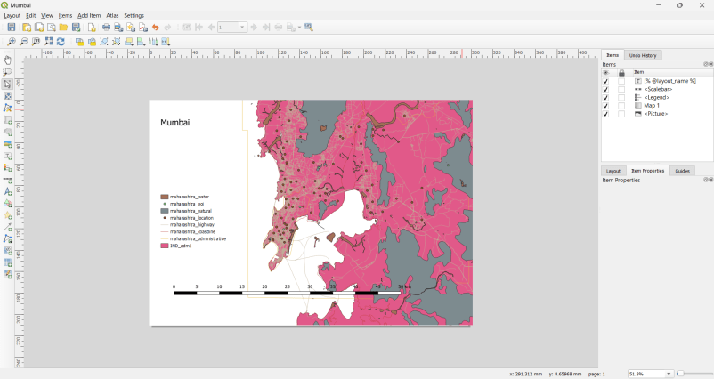

1. Import CSV File

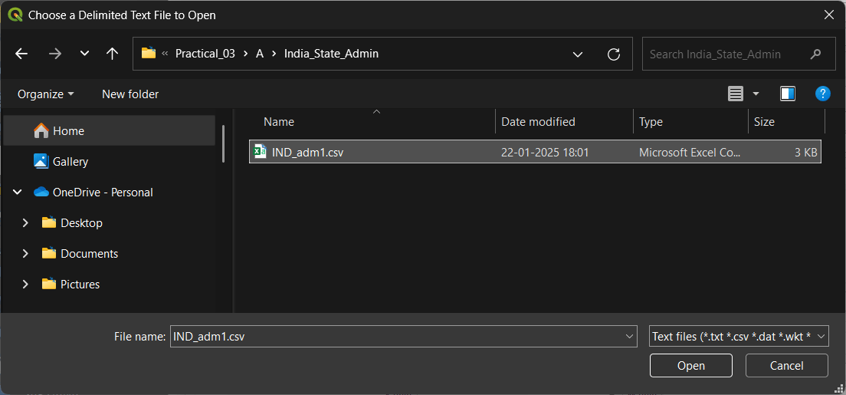

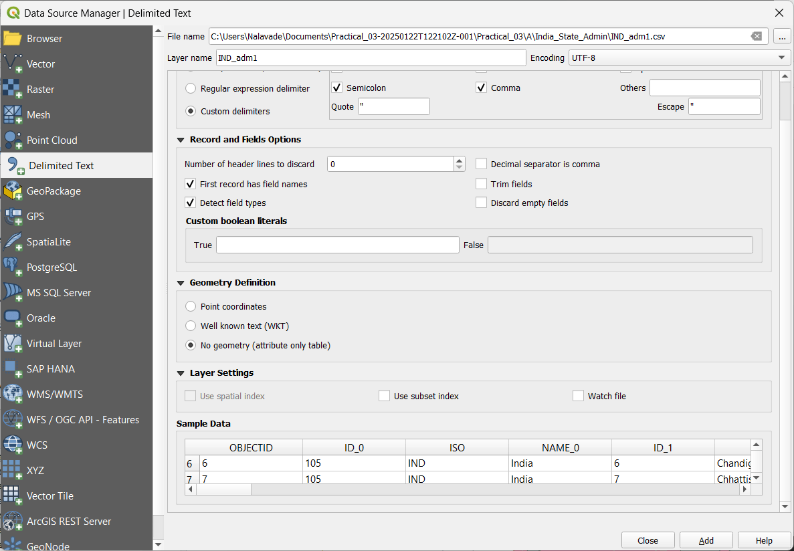

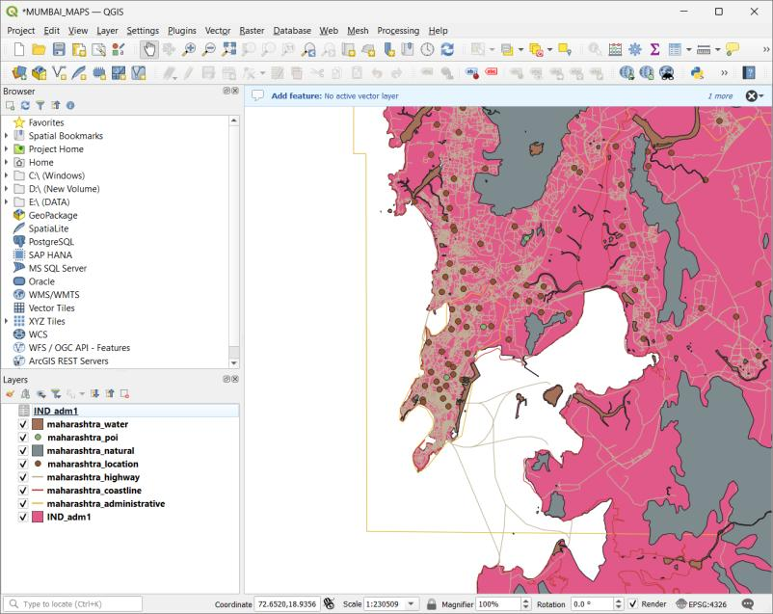

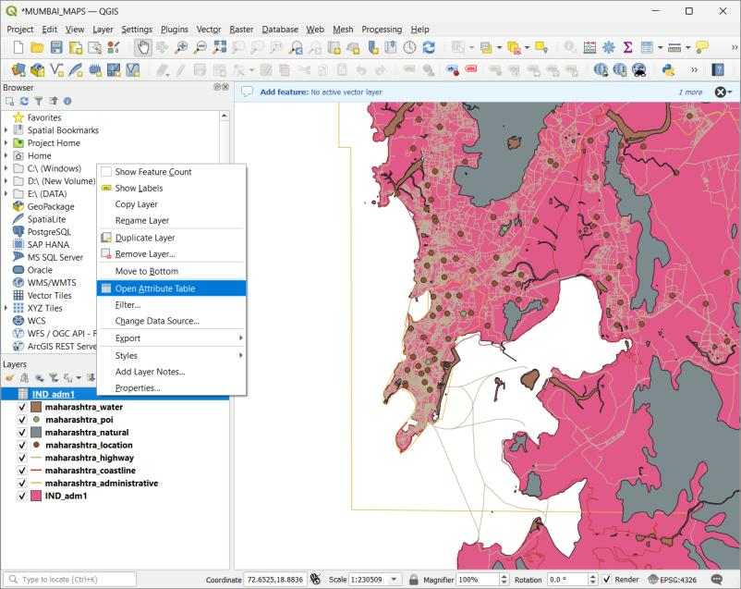

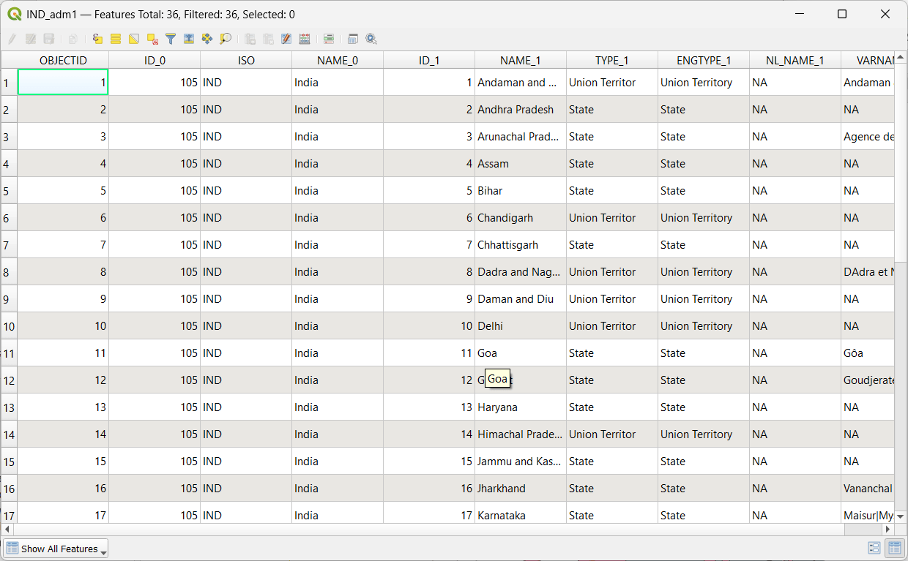

We can see csv data in attributes table

3.] Install and enable plugins (experimental plugins).

SOLUTION:

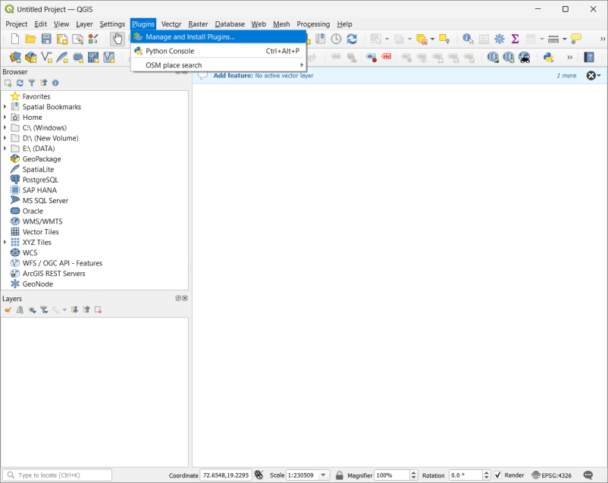

**Step 1: Open QGIS**

1. **Launch QGIS** on your computer.
2. Make sure you have an active **internet connection** (required for downloading plugins).

**Step 2: Open the Plugin Manager**

1. Click on **Plugins** in the top menu bar.
2. Select **Manage and Install Plugins…**.
3. The **Plugin Manager** window will open.

**Step 3: Enable Experimental Plugins**

1. In the **Plugin Manager**, click the **Settings** tab.
2. Check the box that says **Show also experimental plugins**.
3. Click **OK** or **Close** to save settings.

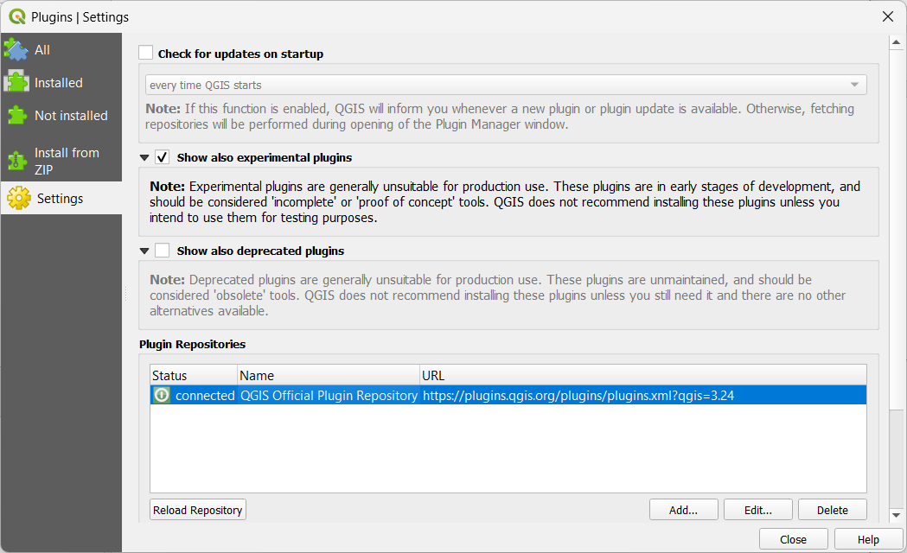

**Step 4: Install a Plugin**

1. Go back to the **All** tab in the Plugin Manager.
2. In the search bar, type the name of the plugin you want to install (e.g., **QuickMapServices** for adding more basemaps).
3. Select the plugin from the list.
4. Click the **Install Plugin** button.
5. Wait for the installation to complete.
6. Click **Close** after installation is successful.

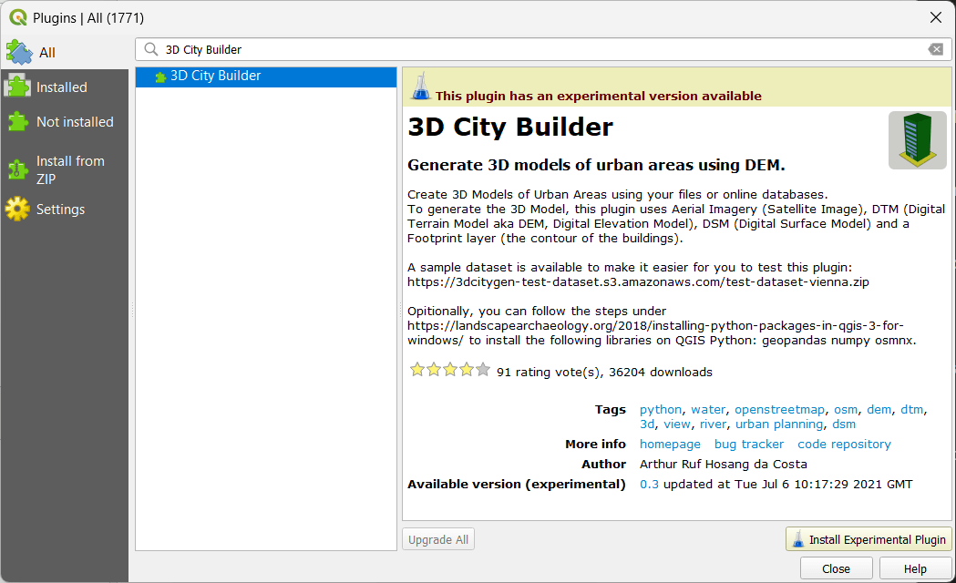

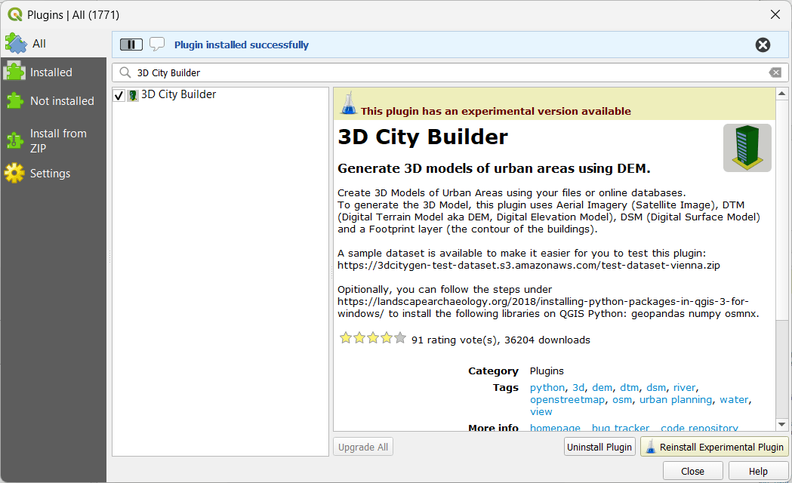

**Step 5: Enable the Installed Plugin**

1. Go to **Plugins** → **Manage and Install Plugins…**.
2. Click on the **Installed** tab.
3. Find your installed plugin and check if it is **enabled** (checked).
4. If not enabled, select it and click **Enable**.

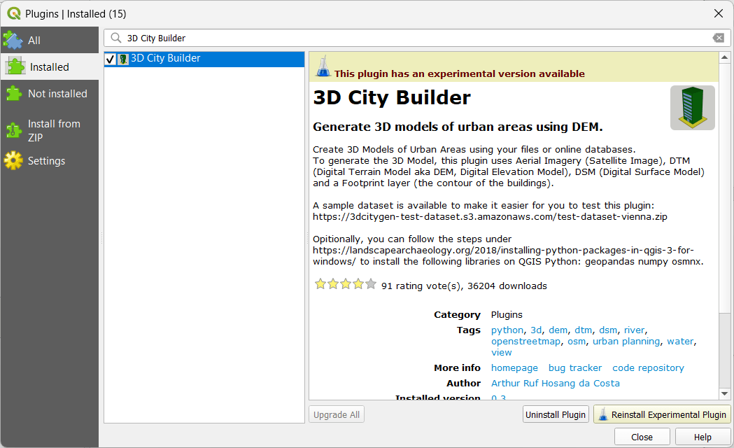

**Step 6: Use the Installed Plugin**

1. Once enabled, the plugin will appear in:
   * **Toolbar** (e.g., QuickMapServices appears in the Web toolbar).
   * **Processing Toolbox** (for geoprocessing plugins).
   * **Layer Panel** (for data-related plugins).
2. Open and use the plugin as per your needs.

**Step 7: Verify Installed Plugins**

1. Go to **Plugins** → **Manage and Install Plugins…**.
2. Click on the **Installed** tab.
3. You will see a list of **all active plugins**.

**Step 8: Uninstall or Disable a Plugin (Optional)**

1. Go to **Plugins** → **Manage and Install Plugins…**.
2. Click on the **Installed** tab.
3. Select the plugin you want to remove.
4. Click **Uninstall Plugin** (if removable) or **Disable** (to turn it off).

4.] Import “10n060e_20101117_gmted_mea300.tif” raster data which represent surface elevations map of India.

To study the elevation of hilly area of North India, extract the required Raster area by Extent. Perform Terrain analysis using the above elevation map.

(Dataset : <https://drive.google.com/drive/folders/1UBl0nPFZCkDAx2vvqeHG_N47-Hv1EiqP>)

SOLUTION: [PRACTICAL SAME AS JOURNAL 5(B) TERRAIN DATA]

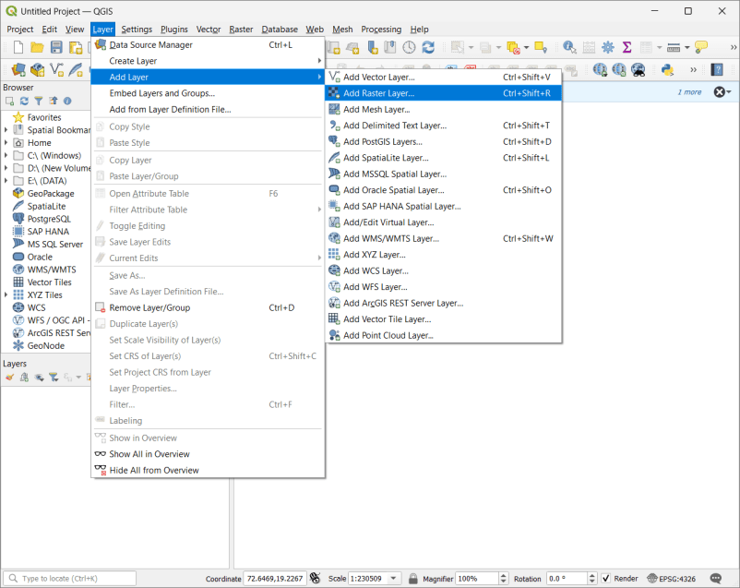

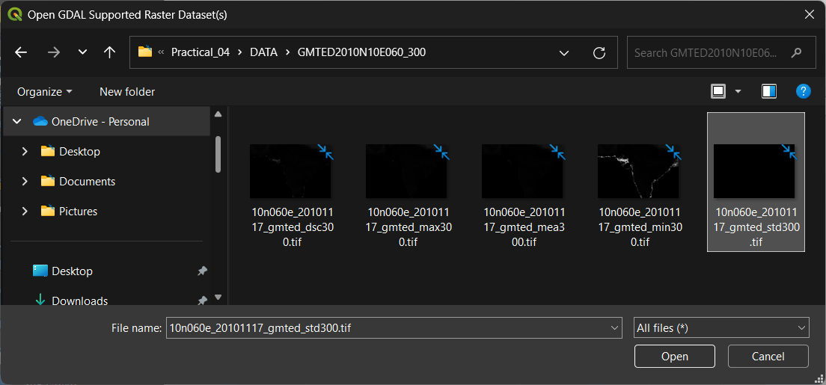

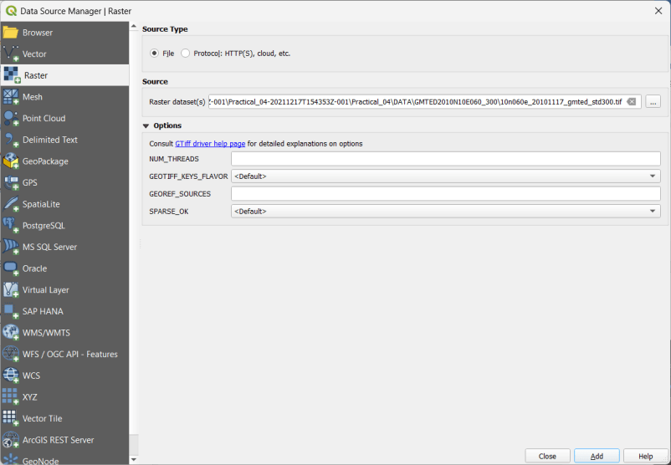

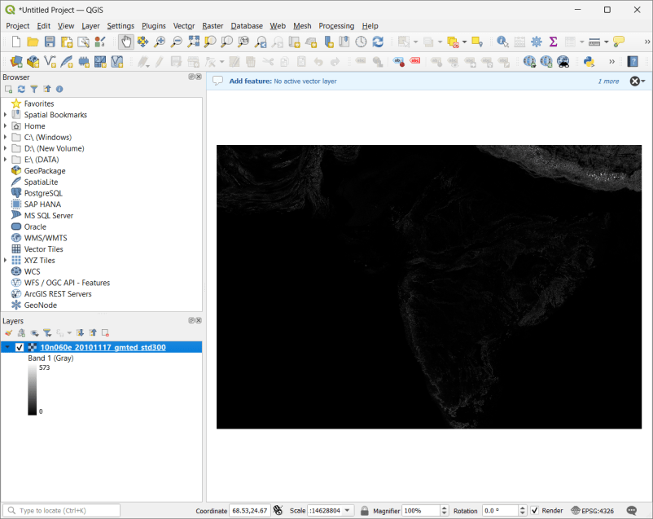

Change the coordinates in bottom right corner of the tab

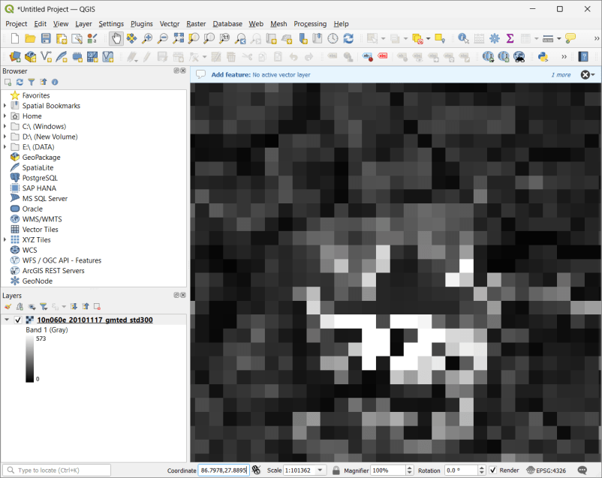

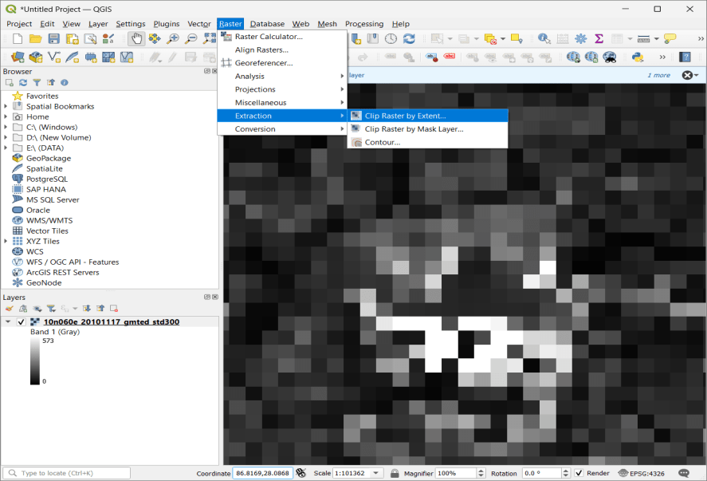

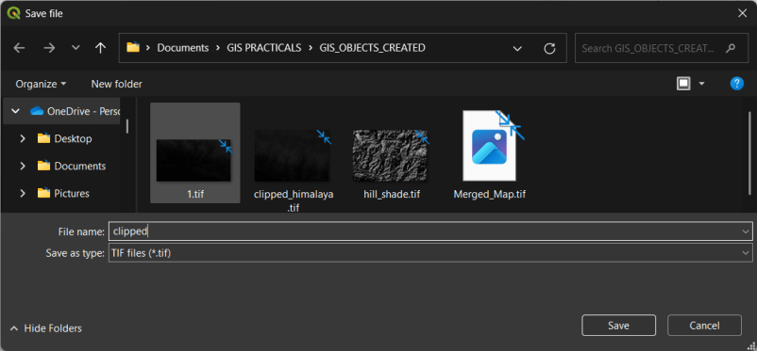

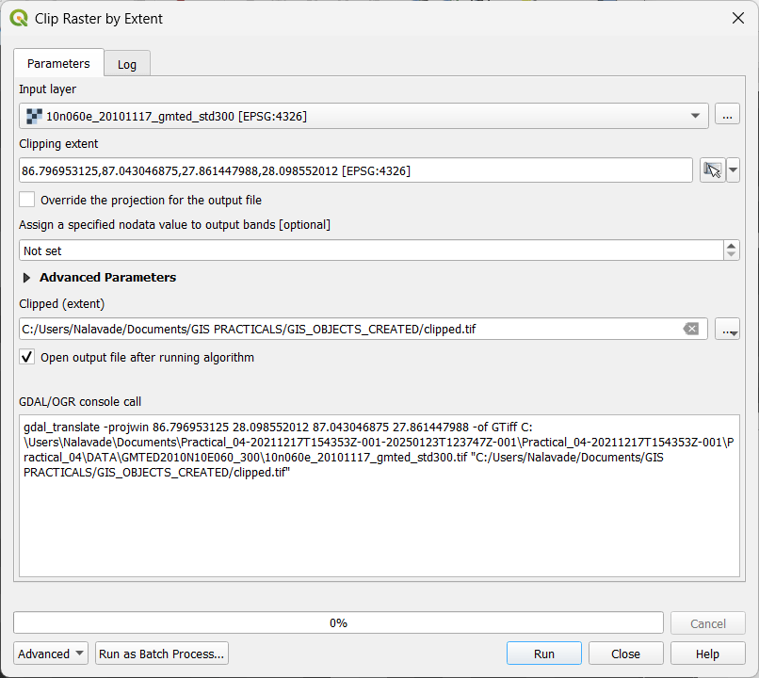

After Run

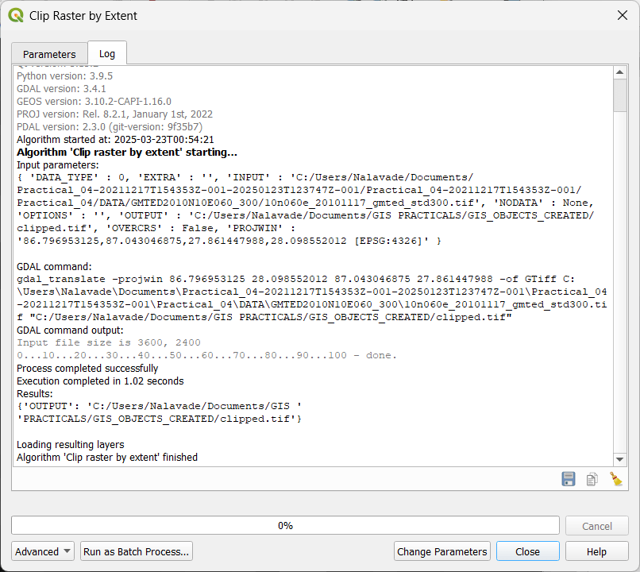

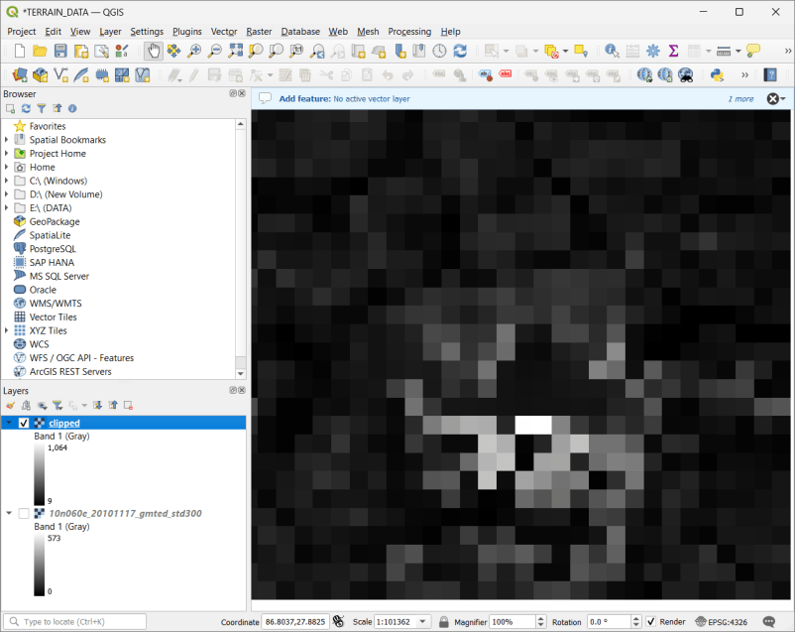

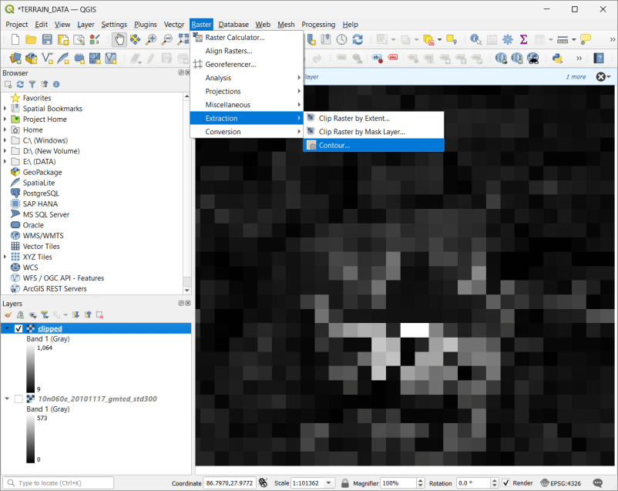

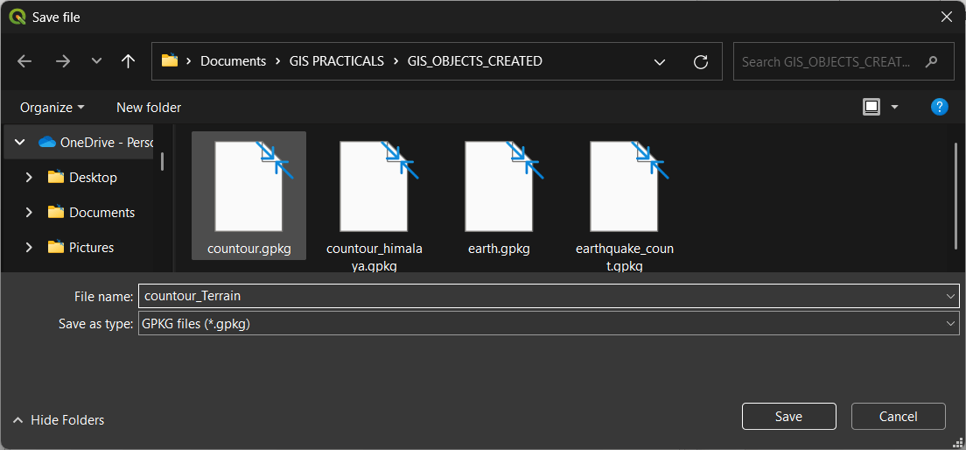

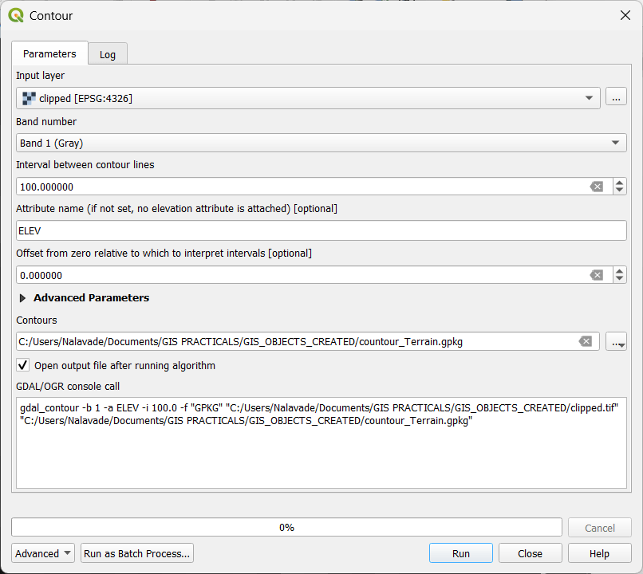



After Run

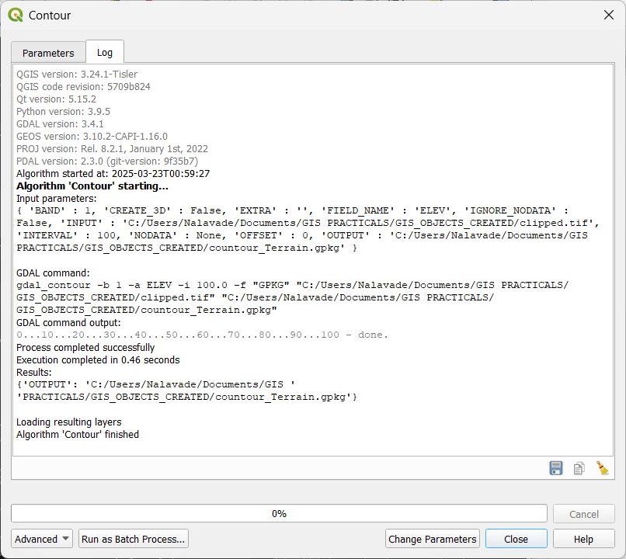

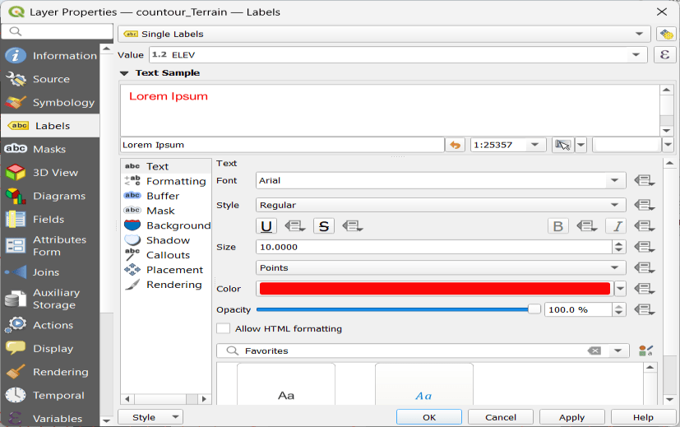

The result will be: (Use clipper tool from raster and use appropriate attributes, set interval between contour 100.)

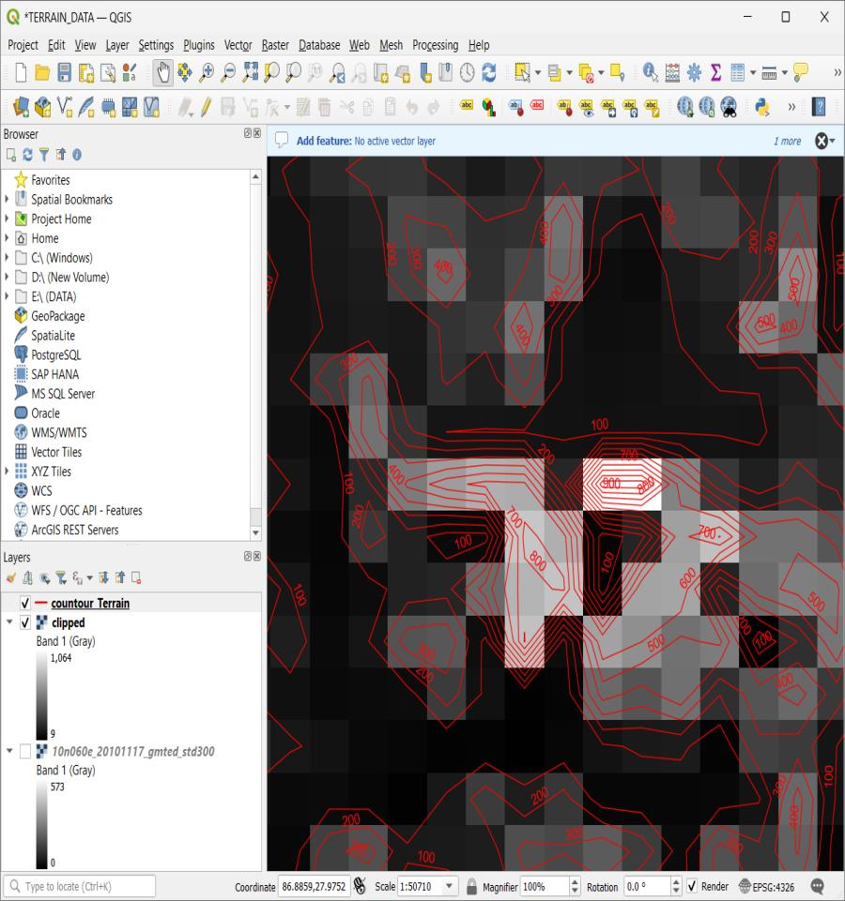

6.] Add vector layers, use this file **“\IND_rails.shp and \IND_adm0.shp”** from database, set all appropriate properties, formatting and calculate line lengths and statistics in India.

(Dataset : <https://drive.google.com/drive/folders/1KEJc4EYCfodvuY6OGN8Ar-d87LPQBb1k>)

SOLUTION : SAME AS PRACTICAL 1 of Journal

Go to Layer -> Add Layer -> Add Vector Layer

Add the following file to project

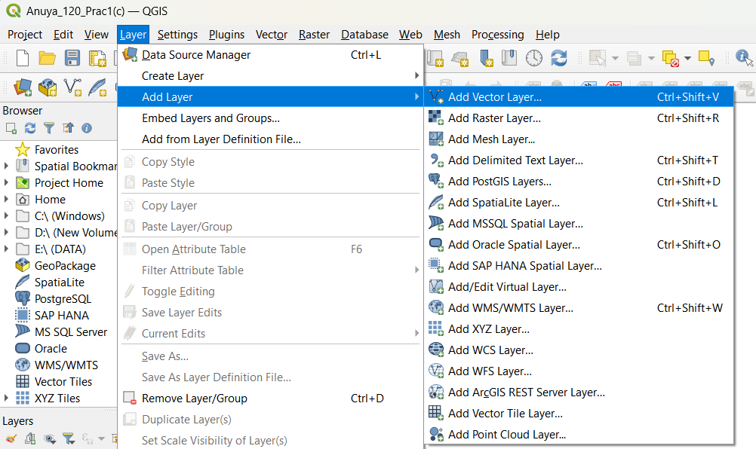

C:\Users\Nalavade\Downloads\Practical_01-20211217T154344Z-001-20250120T173530Z-001\Practical_01-20211217T154344Z-001\Practical_01\D\DATA\IND_rrd

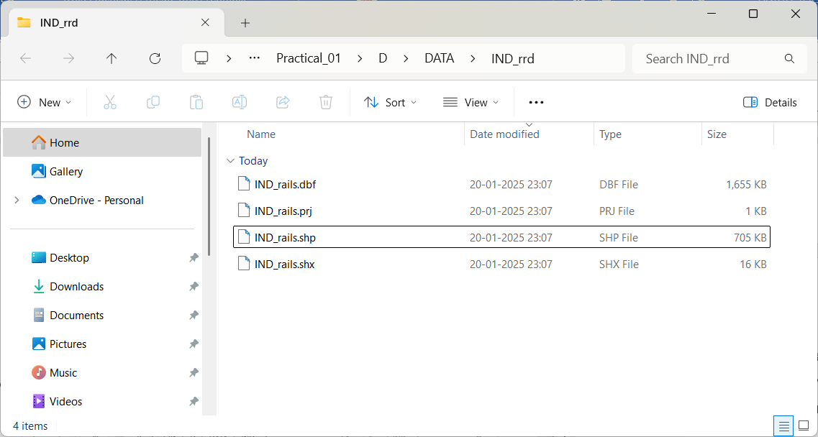

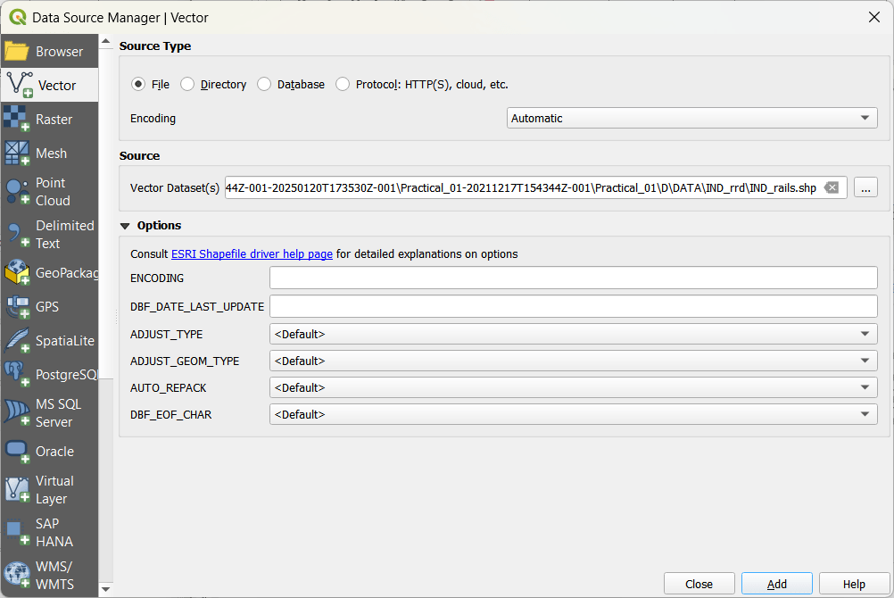

Click Add and Close. You will see the below map appearing.

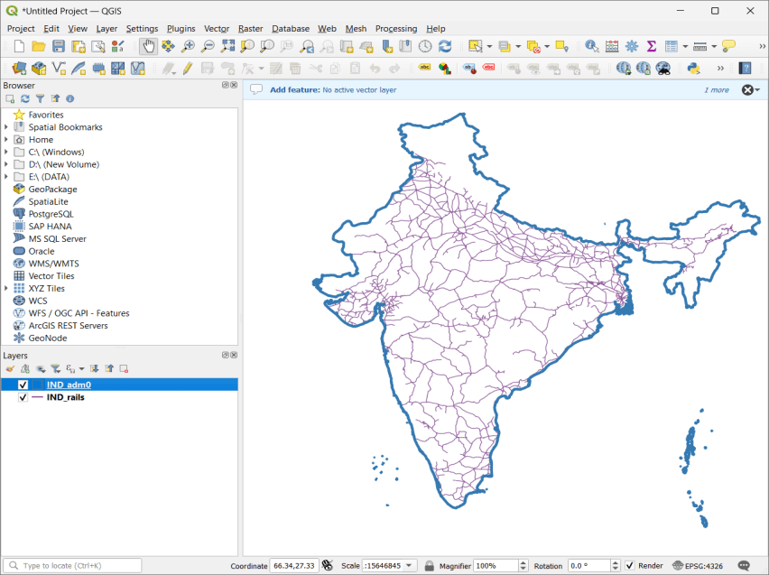

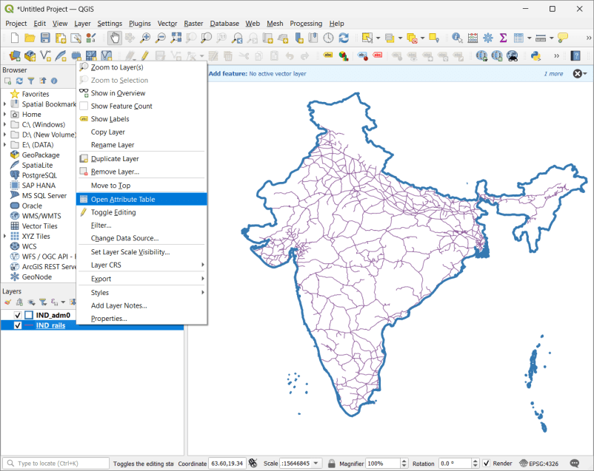

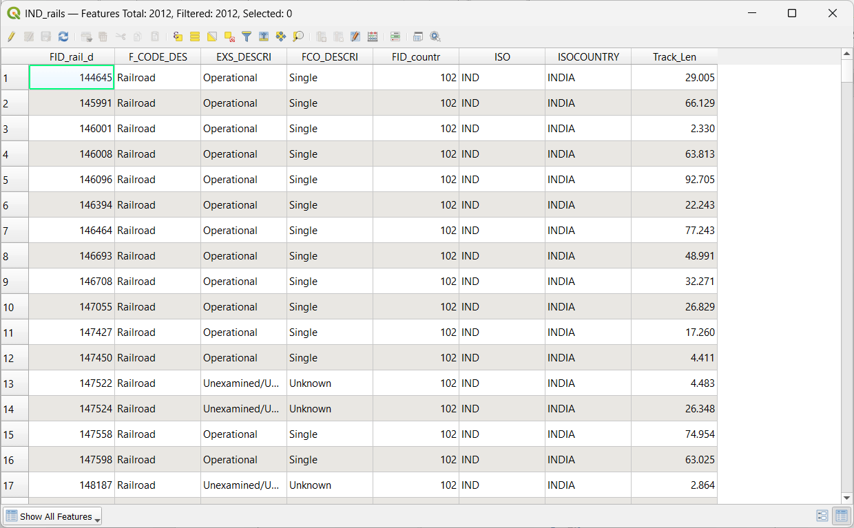

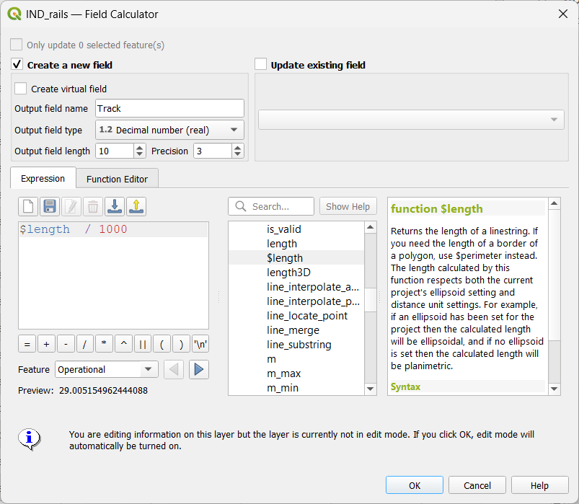

A new column is added to the attribute table with value representing the length of track in KM.

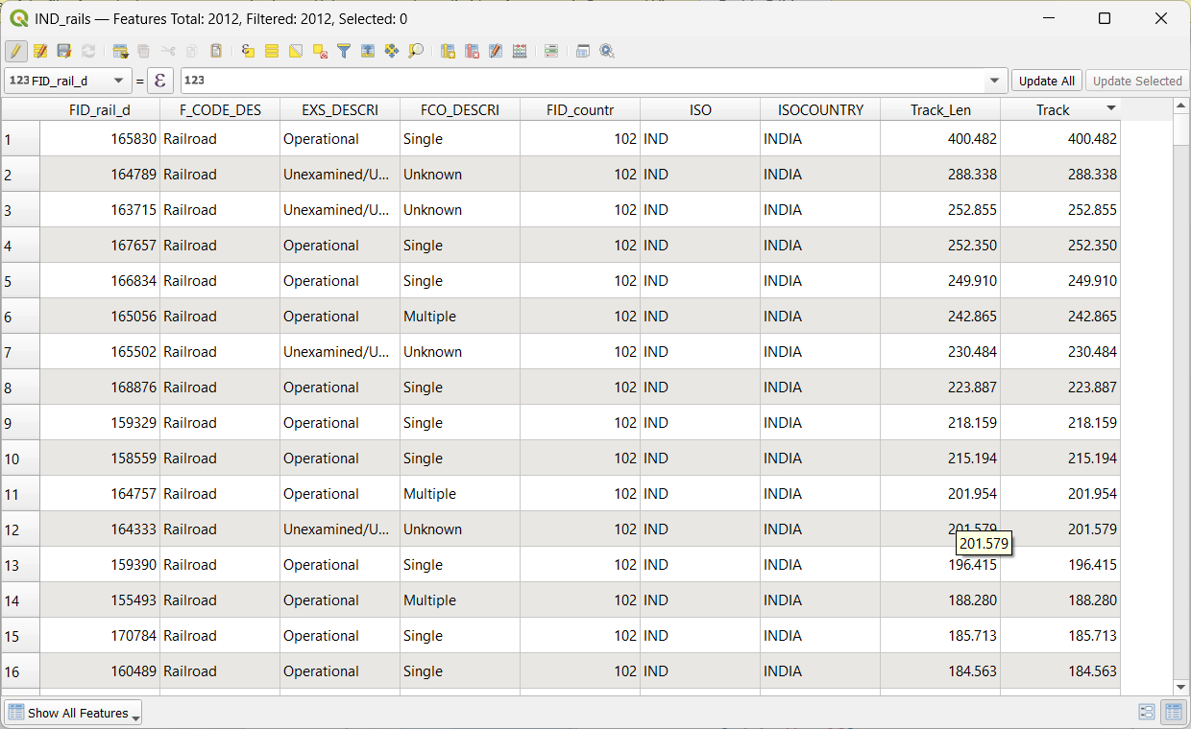

Press CTRL + S or click on Save Edits option on tool bar

Close the attribute table window

For calculating the total length of Railway tracks in India.

Select Vector -> Analysis Tools -> Basic Statics for Fields

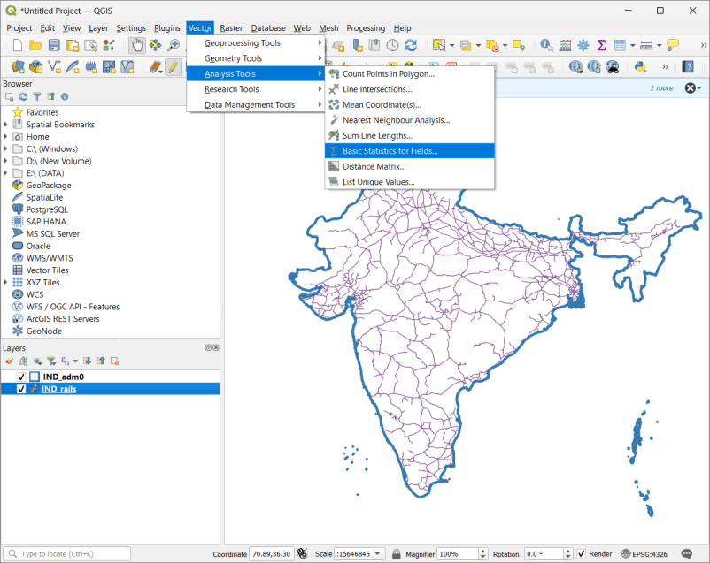

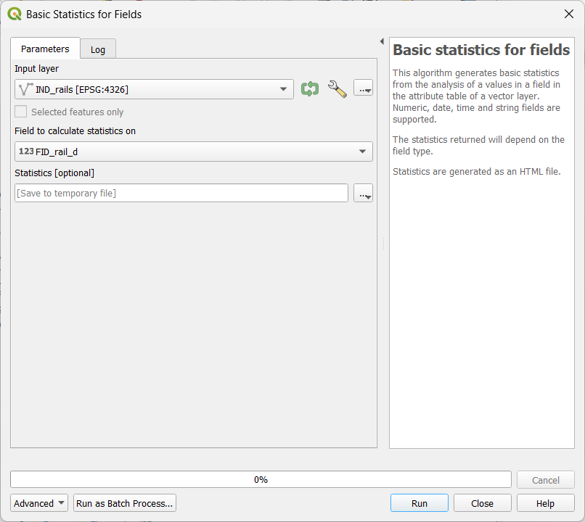

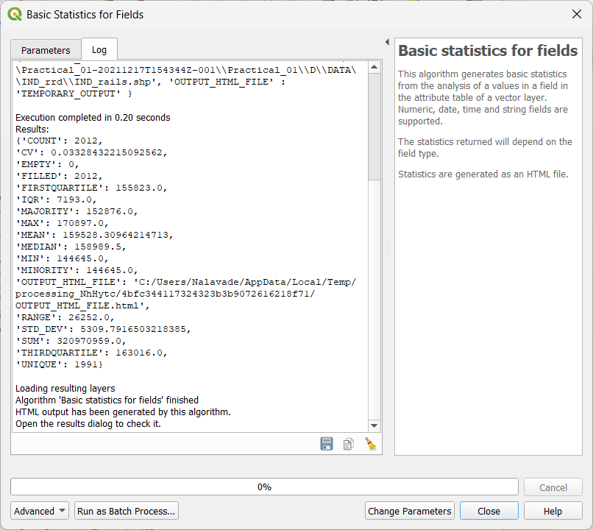

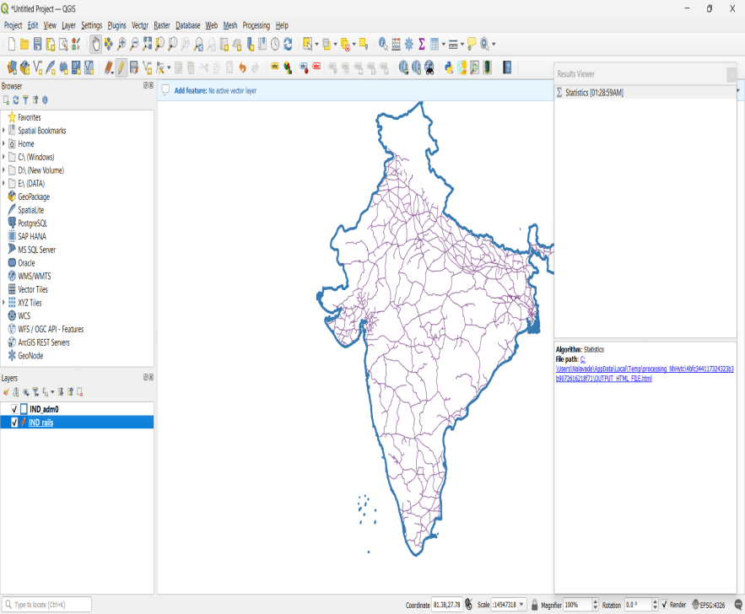



Click on this will get the output:

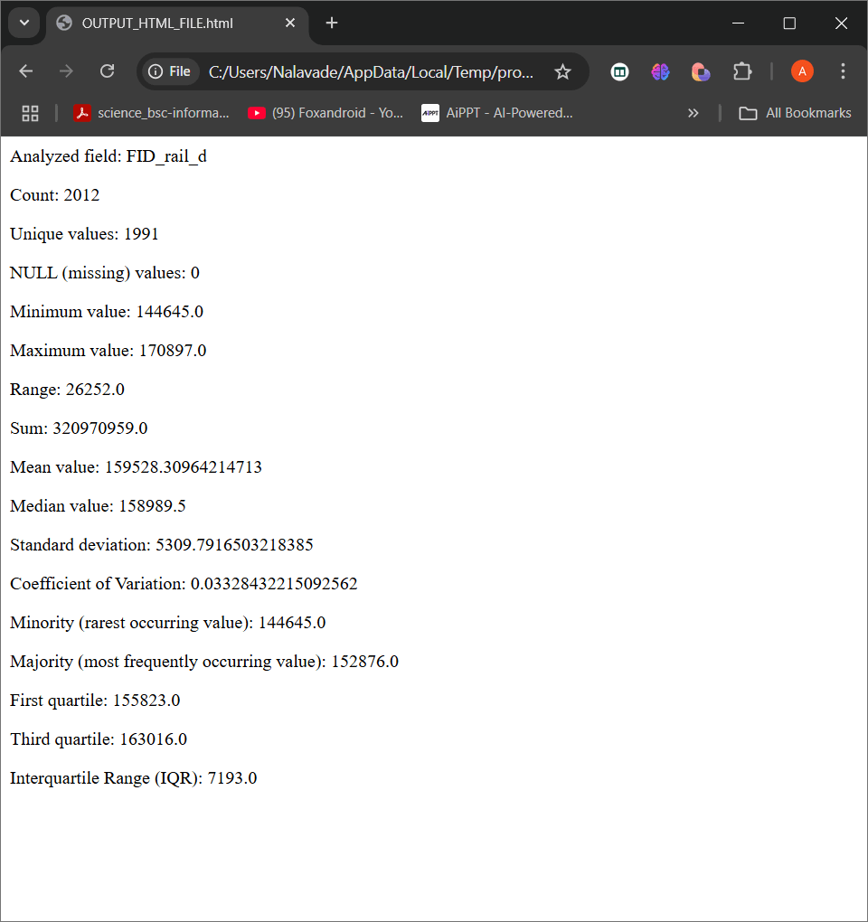

7.] Add raster layers, use “**gl_gpwv3_pdens_90_ascii_one\glds90ag60.asc**”:

1. Set Properties, symbology
2. Apply raster styling and analysis

Write all the steps and show proper output   
(Dataset : <https://drive.google.com/drive/folders/13flVLI7vqZ1R3ur7aexlSWHYMb8pX6RX> )

SOLUTION:

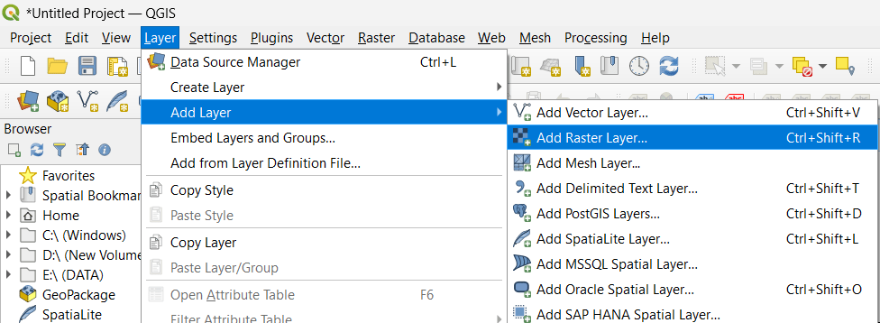

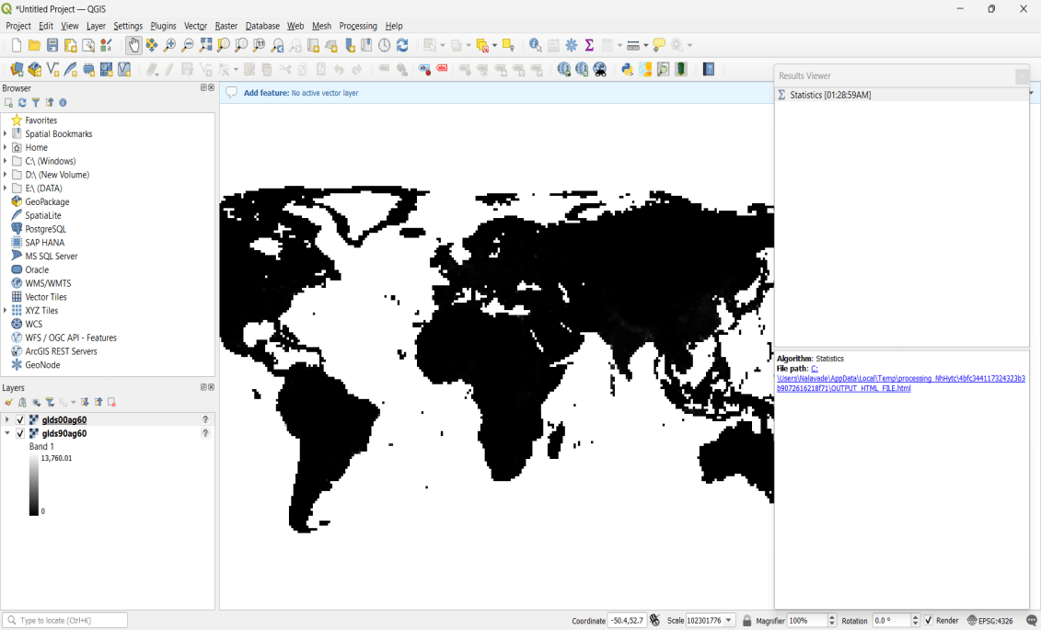

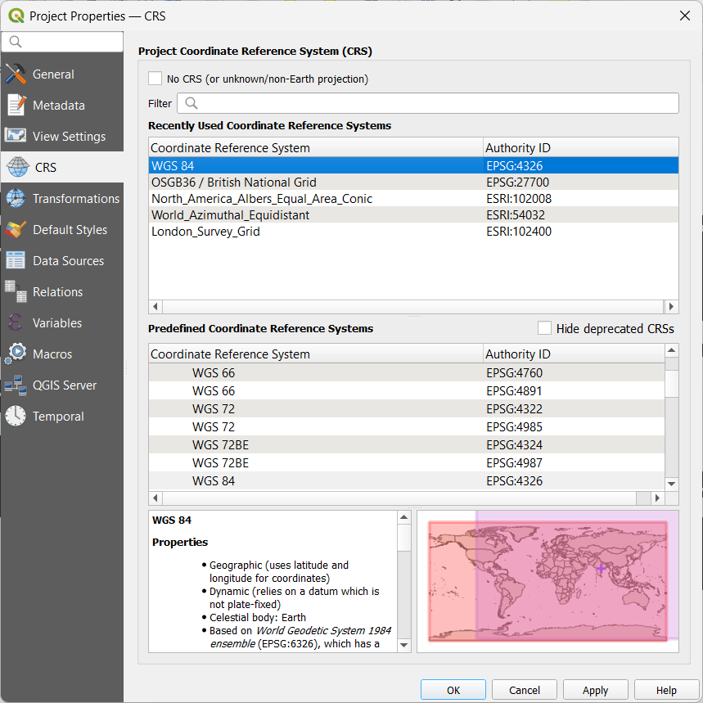

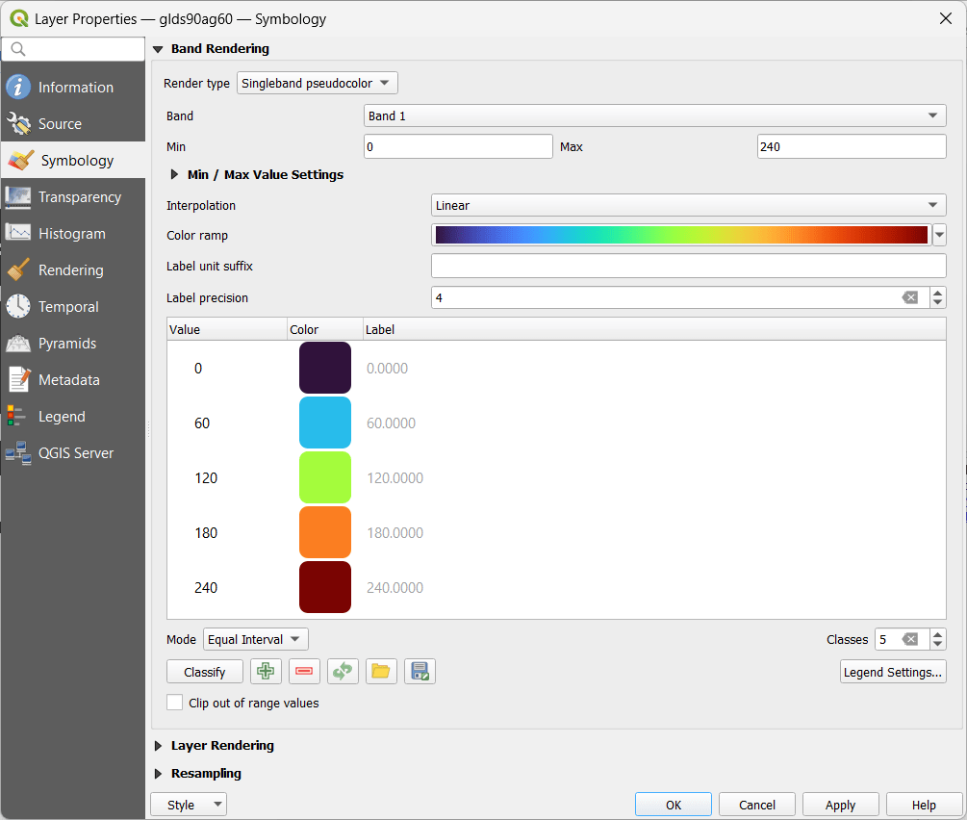

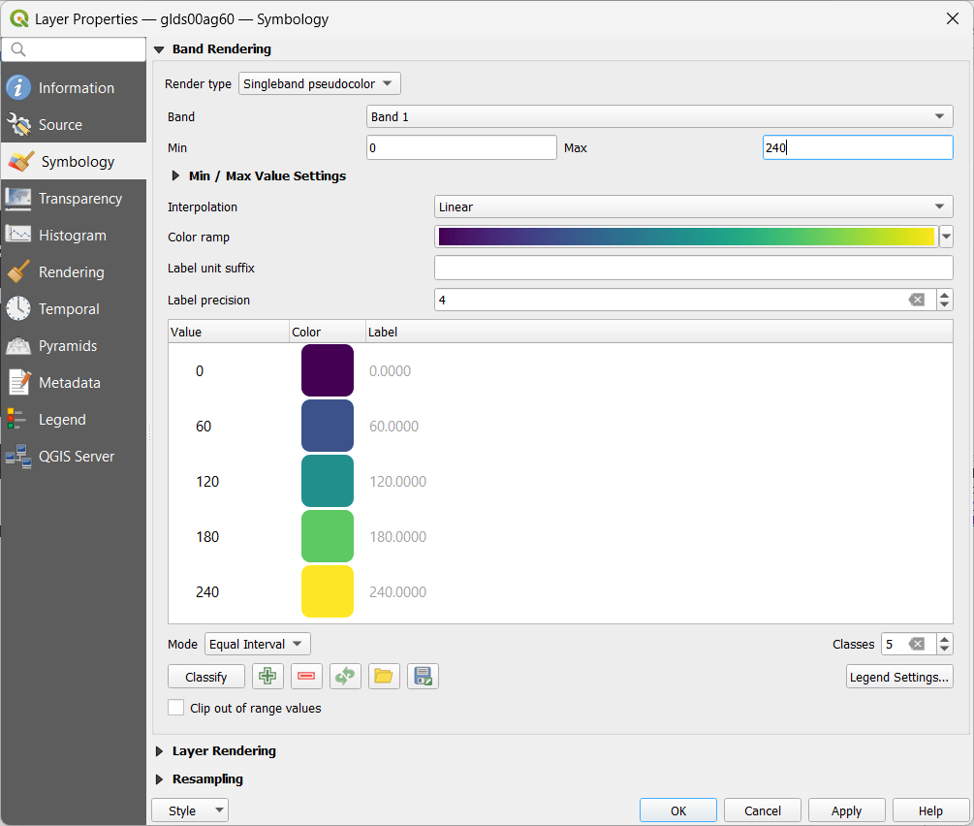

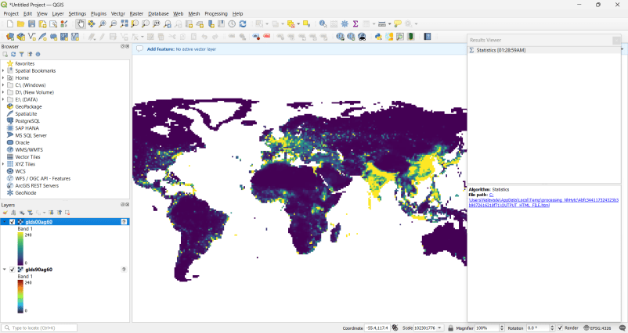

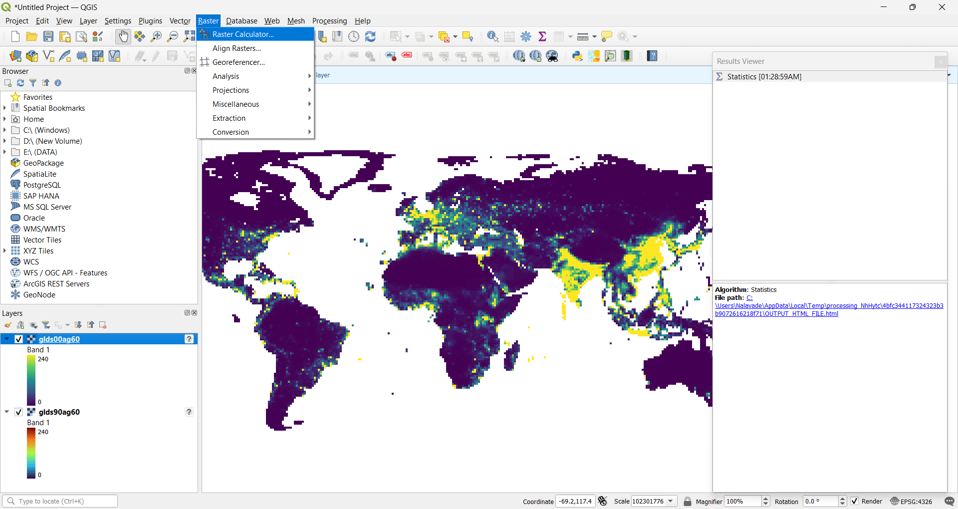

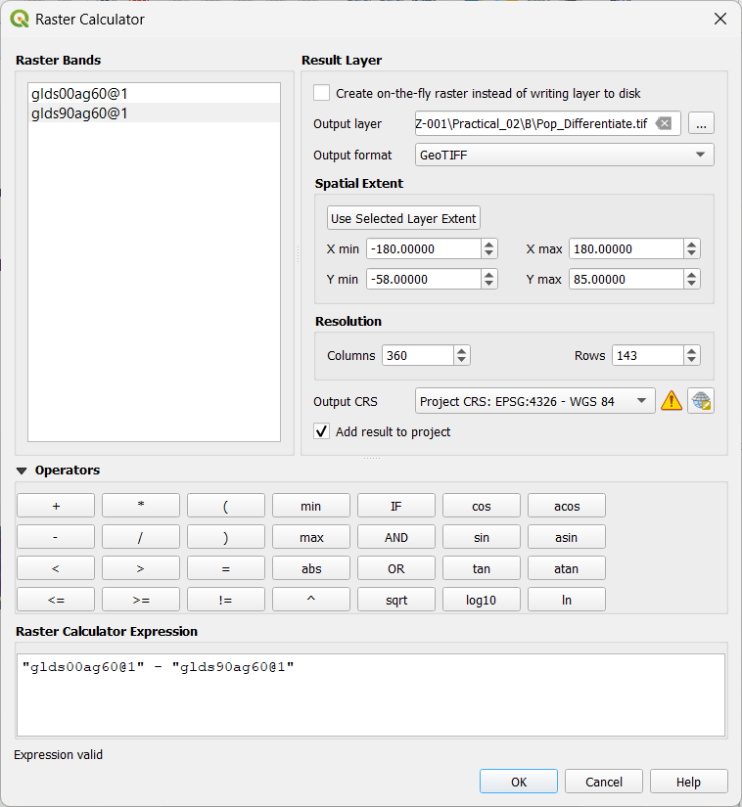

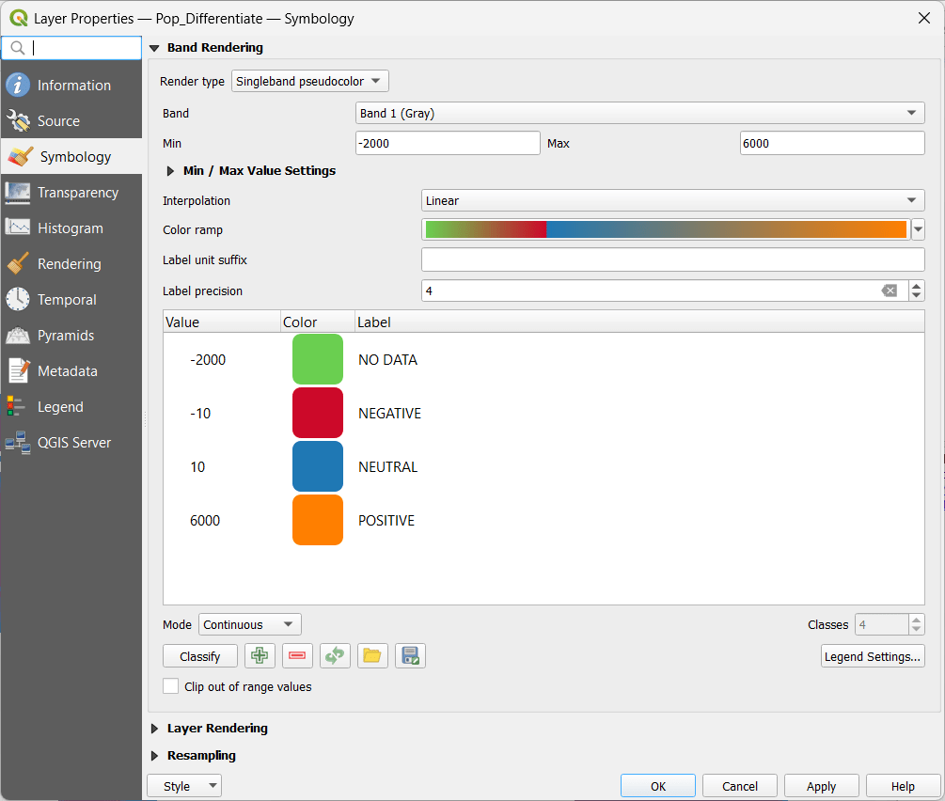

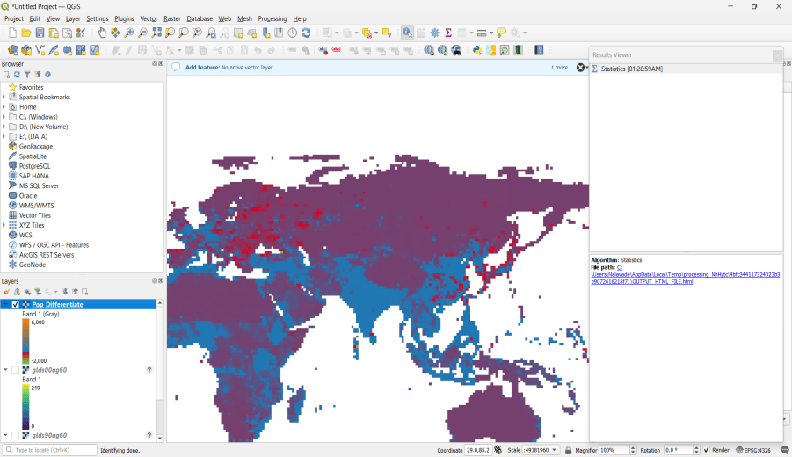

8.] Add ne_10madmin_0_countries.zip layer:

1. Save with shape file
2. Add raster layer with R17.tif

Set appropriate properties and show output with grid EPSG 27700.  
(Dataset: https://drive.google.com/drive/folders/1h5YSX2A2d7dYe8yZ7_z7dg6F8-E2mUjm)

SOLUTION: (SAME AS PRACTICAL 6 JOURNAL) 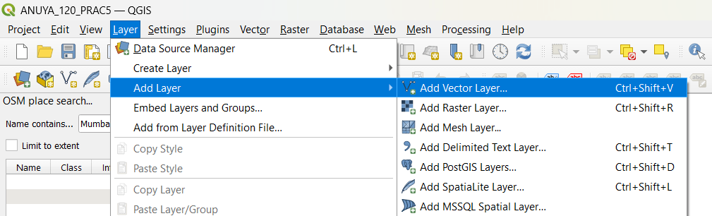

➢ Select “ne_10m_admin_0_countries.zip” Layer from data folder.

Location Directory : C:\Users\Nalavade\Downloads\Practical_05-20250122T182606Z-001\Practical_05\ne_10m_admin_0_countries.zip

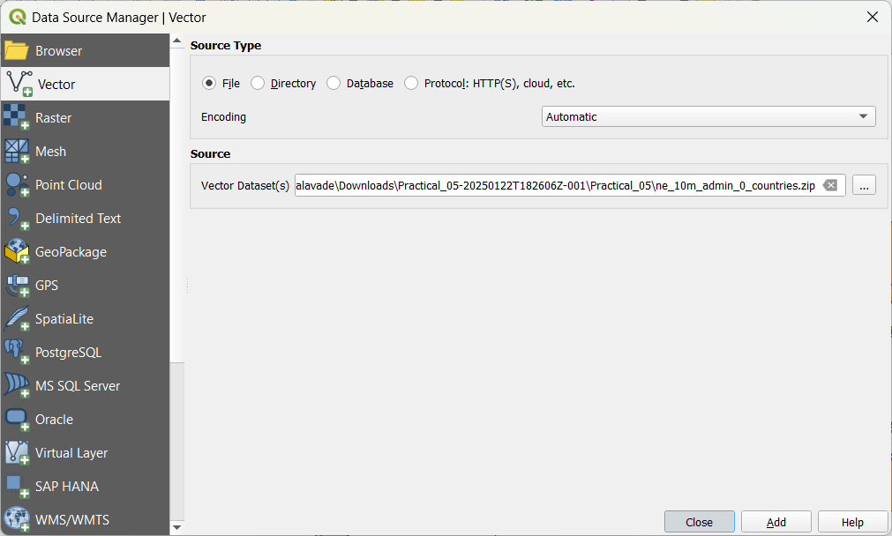

Select add and then close.

➢ Go to Layer → Save As

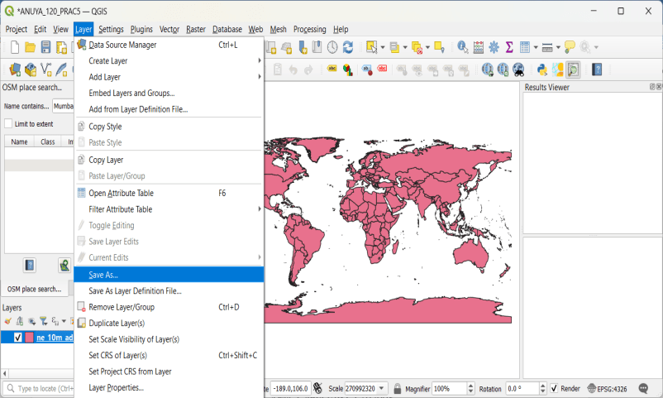

Select format as ESRI Shape File

Select folder location and file name

Set CRS North_America_Albers_Equal_Area_Conic EPSG: 102008

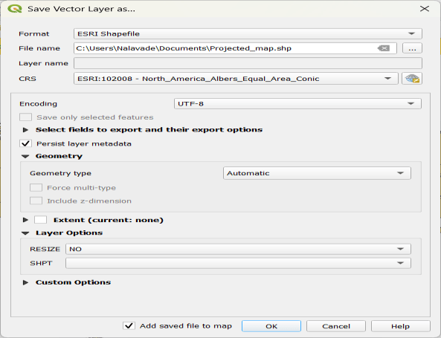

➢ Go to Layer → Add Layer → Add Raster Layer.

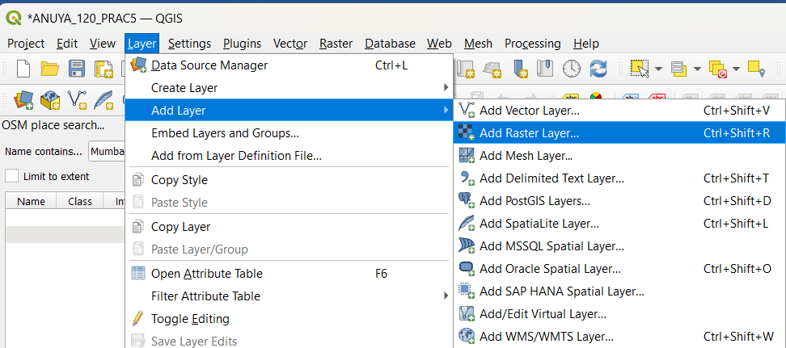

C:\Users\Nalavade\Downloads\Practical_05-20250122T182606Z-001\Practical_05\minisc_gb\minisc_gb\data\RGB_TIF_compressed\MiniScale_(standard)_R17.tif

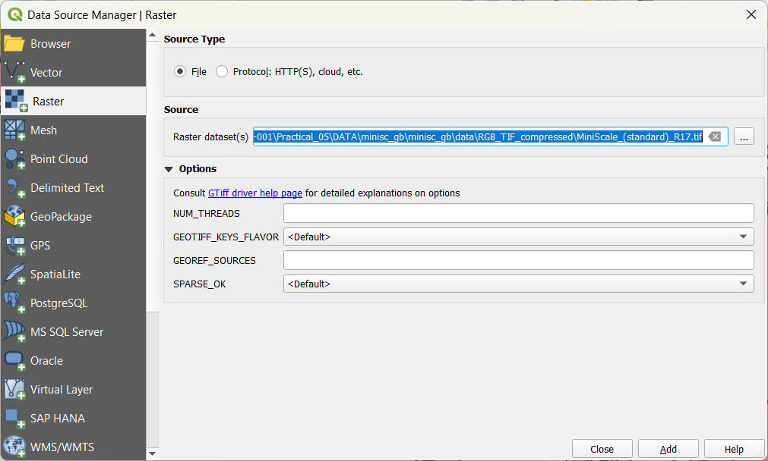

You will get this:

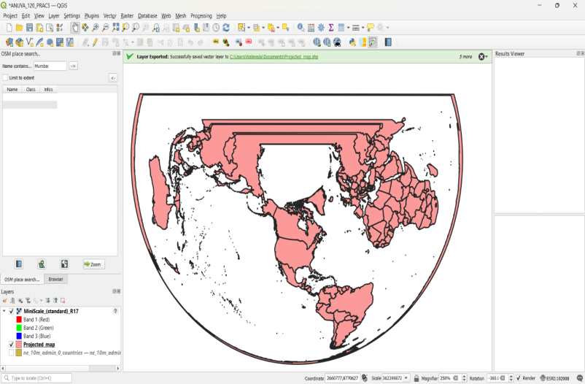

➢ Go to Project → Properties.

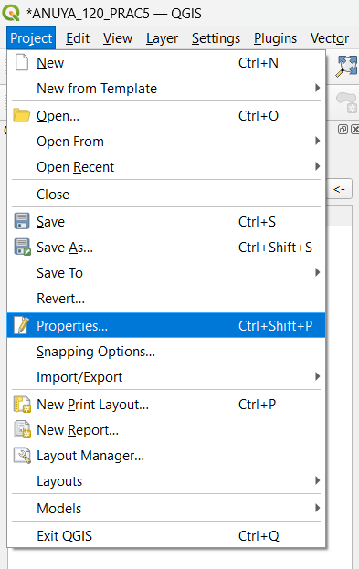

➢Open Layer Properties -> CRS -> Search bri -> select British National Grid EPSG 27700

➢ Processing may take some time

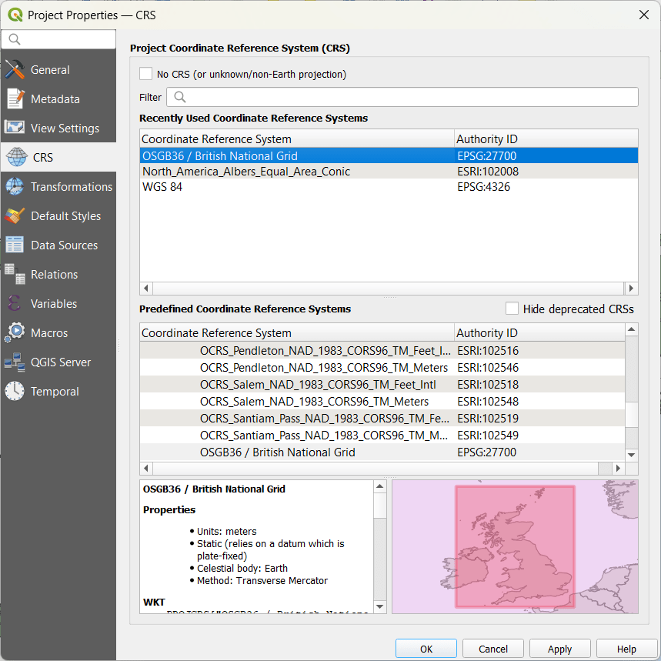

In Select Transformation, you will be able to see what option got selected you will see.

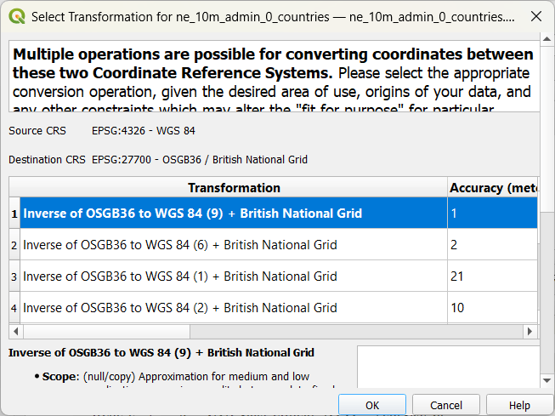

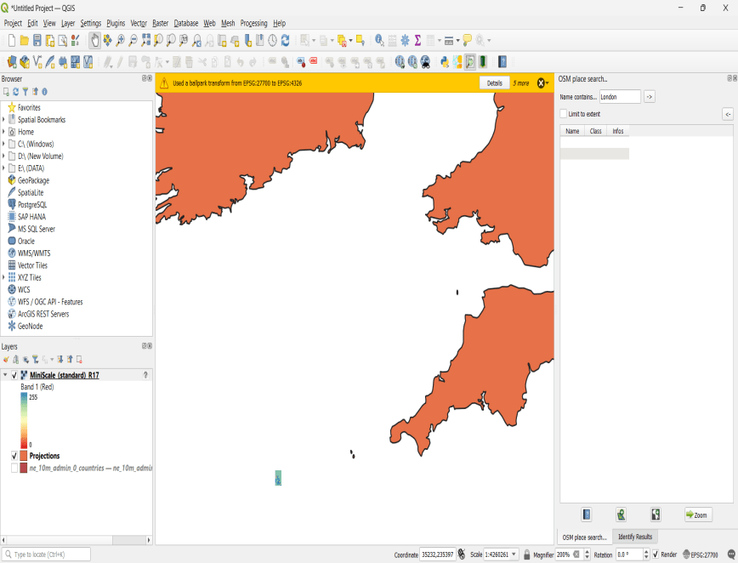

The result will be:

